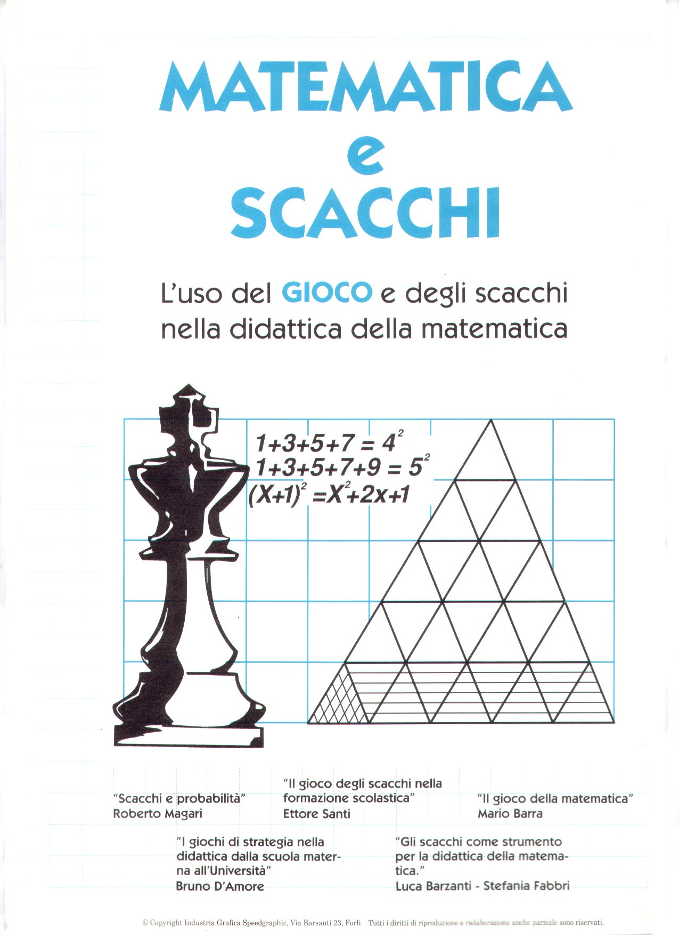

Matematica

e

Scacchi
Atti del Convegno

Forlì, 18 Settembre 1992

INDICE

Prefazione pag. 4

Relazioni:

Edmar Mednis: Q+R? Vs. Q Endgames: Accepted theory and
latest developments (Versione originale in inglese) pag. 05

Edmar Mednis: Q+R? Vs. Q Endgames: Accepted theory and
latest developments (Versione tradotta in italiano) pag. 18

Ettore Santi: II gioco degli scacchi nella formazione scolastica pag.31
Bruno D'Amore: I giochi di strategia nella didattica dalla scuola
Materna all'Università pag. 46
Luca Barzanti e Stefania Fabbri: Gli scacchi come strumento
per la didattica della matematica pag.54

Roberto Magari: Scacchi e probabilità pag. 68

Improrogabili impegni di natura accademica non hanno consentito al Professor Mario Barra di portare il suo contributo al Convegno.
Siano altresì lieti di pubblicare un capitelo del lavoro da cui il G.M.
Edmar Mednis ha tratto il sue intervento.

Prefazione :

II porsi del Convegno come punto d'incontro tra due discipline così distanti nelle strutture e negli apparati ne ha reso l'organizzazione ancor più affascinante.
Il merito è certamente di chi, nell'uno e nell'altro settore, ha saputo apprezzare la novità e la ricchezza dell'idea, contribuendo in modo essenziale alla sua concreta realizzazione.
I Comuni di Forlì e di Forlimpopoli, la Lega Scacchi Uisp, l'organizzazione del
Torneo Internazionale, l'Associazione scacchistica e culturale Popilia e la sezione
di Forlì di Mathesis sono coloro che con grande impegno hanno reso possibile l'iniziativa, ma anche il sostegno del Provveditorato agli Studi di Forlì è stato fondamentale per collegarci con il mondo della scuola, che riteniamo interlocutore essenziale per la prosecuzione del nostro lavoro.
Un sentito ringraziamento va infine ai relatori, docenti di chiara fama ed esperti nel settore, i cui contributi, che qui raccogliamo, saranno certamente utili a chi, da ogni parte d'Italia, ha manifestato vivo interesse per la novità che proponiamo e desidera sperimentarla nel proprio ambito.
Luca Barzanti - Stefania Fabbri

Si ringraziano:
la Facoltà di Scienze Politiche, per la concessione della sala Albertini,
la Cassa dei Risparmi di Forlì, Ferruccio Ferucci,
Piero Carapri.

Q + RP Vs. Q Endgames: Accepted Theory and Latest Developments

By Edmar Mednis

In an article in the February-March 1981 issue of CHESS I, discussed the important developments up to then for the Q + RP vs.Q endgame.
Of all the Q + P vs. Q endgames, the case with a RP is the most important one for the practical player.
This is because it is the one that occurs most frequently and the reason for this is also quite understandable: the RP is the pawn least likely to have been exchanged off in earlier play.
In the above article I made the recommendation that a major chess computer program be used to do the work in analyzing the Q + P vs, Q endgame.
The small number of pieces remaining on the board makes this endgame quite analyzable for the programs with lots of "brute force".
On the other hand, the extreme tediousness of such endgames makes them very unpleasant for a human analyst.
In 1985 my wish was answered: the former World Champion computer chess program BELLE spent the better half of its time that year in undertaking a definitive study of this endgame.
In the process BELLE has generated a "truckload" of information.
Unfortunately, the very extensivness of it makes the job of a human in tackling it still very hard.
Because I had published work on the Q + RP vs. Q endgame, I decided to take advantage of BELLE's "expertise” and calculating ability in this area.
I selected the six endgames from recent tournament play that seemed to me to be the most important ones theoretically and asked BELLE to comment on them, thus providing both evaluations and analysis to us humans.
This article is based on the results from BELLE'S work.
I am greatly indebted to Ken Thompson, the chief "brain" behind BELLE and to International Master Mike Valvo for their help and cooperation in fulfilling my request and explaining BELLE'S "thinking".
An important aspect of the latter is that because of its 1985 work, BELLE has
developed an extensive database of positions which are won and drawn.
Because it believes in playing "objective chess" BELLE refuses to play out for a
win those positions which, according to its program, are theoretical draws.
Therefore for such positions we can not learn what the best winning tries are.
My method will consist of presenting the endgames as BELLE sees them.
I will explain why the moves played are good and bad and will compare BELLE'S conclusions with those of noted human analysts.
As will be seen, the humans are wrong a lot.
The reason is that - as I indicated earlier - this is the most difficult endgame for us to analyze.
Implicit in my presentation is my belief hat there is no reason to doubt BELLE's analysis.
I will discuss here two of the endgames: first where the humans play the worst and then the best played one.
At the end of the column I will summarize the major results from the study of all six of the endgames.

Endgame # 1;
L. Shamkovich - H. Wirthensohn, Biel I960, after White's 77th move..

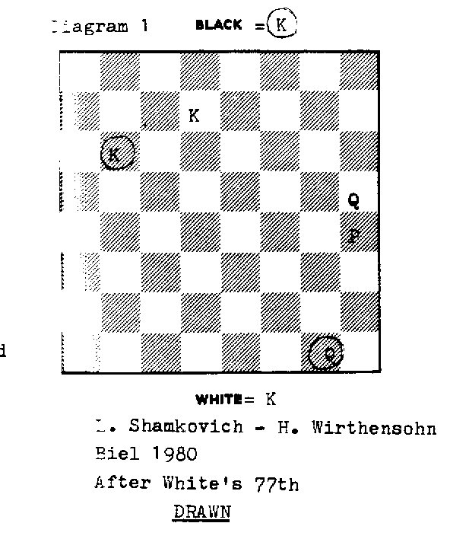
Diagram 1

White has just captured Black's h-pawn to bring about the kind of endgame position which is very important in practical play.
This position is a theoretical draw. Black, understandably enough, is not sure how he should proceed and therefore starts checking:
77...Qg7+, 78 Ke6 Qg8+, 79. Ke7 Qg7+?,
Black's previous two checks were. O.K., but as if continuing by rote, this check is a critical error, because it allows White to significantly improve the position of his Queen.
Correct - and keeping the position drawn - are 79...Qg3 and 79...Qc4.
Both prevent White from significantly improving his Queen's position.
80 Qf7!

From here the Queen shelters the King well (the only reasonable check 80...Qe5+?

is refuted by 81 Qe6+) and by being more centrally placed than on h5 it also covers more board room,
80...Qg3,

Diagrams 2
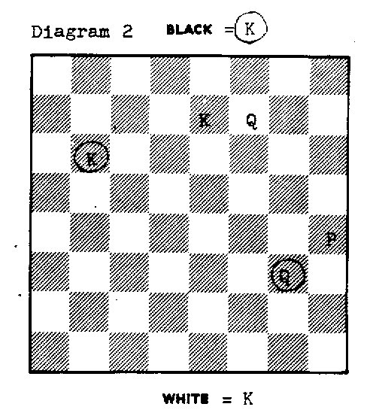
This is a very important theoretical position, because it is won for White.
Notice that this conclusion comes while the h-pawn is still on its fourth rank.
This is the position that I submitted to BELLE for analysis, correctly calling it "won for White .

81 Qf6+

GM Benko points out that White could have immediately played 81 h5, since

Black soon runs out of checks: 81…Qa3+ (Notice that 81...Qh4+?, 81...Qg5+?,

81...Qe3+? and 81…Qe5+? are all answered by an immediate countercheck.)

82 Kf6 Qc3+, 83 Kg6 Qd3+, 84 Kg7.

Please keep noticing how well placed White's Queen is on f7.
However, BELLE has no problems with the text move because it keeps the win in hand.
81...KC7, 82 Qg5?
Both Benko and Shamkovich credit this with a ! mark when in fact it is quite ridiculous.
From f6 the Queen has more scope than on g5 and thus it should not be deactivated unless there is a specific winning reason. In our case there is not.
Sufficient to keep the position won are 82 Kf7, 82 Kf8 and 82 Ke8.
All of these moves free the e7 square for a potentially killing countercheck by White's Queen.
However, strongest is the immediate 82 h5!.
BELLE then provides the following best play for both sides:
82...Qa3+, 83 Kf7 Qa2+, 84 Kg7 Qg2+, 85 Qg6 Qb2+, 86 Kh7 Qb3, 87 h6 Kd7, 88 Qf5+ Kd8, 89 Qf8+ Kd7, 90 Kh8 Kc6, 91 Qe8+ Kc5, 92 Qe5+ Kc6, 93 Kg7 Qb7+, 94 Kf6 Qb1, 95 Qe8+ Kc5, 96 Qh5+ Kc4, 97 h7 Qb6+, 98 Kg7 Qd4+, 99 Kh6 Qd6+, 100 Qg6 Qh2+, 101 Kg7 Qb2+, 102 Qf6 Qg2+, 103 Kh6 Qh1+, 104 Kg6 Qg2+, 105 Qg5 Qc6+, 106 Kg7 Qd7+, 107 Kh6 Qh3+, 108 Kg6 Qe6+, 109 Qf6 Qg4+, 110 Kf7 Qd7+, 111Kg8 Qg4+, 112 Kf8 Qc8+, 113 Kg7 Qg4+, 114 Qg6 Qd4+, 115 Kf8 Qd8+, 116 Qe8 Qd6+ 117 Qe7 Qh6+, 1l8 Ke8 Qc6+, 119 Qd7 Qa8+, 120 Ke7 Qa3+, 121 Kd8 Qf8+, 122 Kc7 Qh8, 123 Qf5 Kb3, 124 Kd7 Qd4+, 125 Ke7 Qc3, 126 Qe6+ Kc2, 127 Kf7 Qc7+, 128 Kg6 Qg3+, 129 Kf6 Qc3+, 130 Kg5 Qg3+, 131 Qg4 Qe3+, 132 Kf6 Qb6+, 133 Qe6 Qd4+, 134 Kg6 Kd1, 135 Kf7 Qa7+, 136 Qe7 Qd4, 137 Qc7 Qd5+, 138 Ke8 Qe4+, 139 Qe7 Qg6+, 140 Kd8 Qb6+, 141 Qc7 Qf6+, 142 Kc8 Qa6+, 143 Qb7 Qc4+, 144 Kd8 Qh4+, 145 Qe7 Qh5, 146 Kc8 Kc2, 147 Kb8 Qh3, 148 Qg7 Qb3+, 149 Qb7 Qh3, 150 Qc8+,
Two over-all conclusions are apparent from the above sequence:
(1)How inordinately difficult it is for a human to come up with "best play".
(2) It takes more than 50 moves to win from the time the pawn reaches the 7th
rank. Therefore, FIDE' needs to extend its 50 move rule for such endgames.
I should add that it is well recognized in endgame theory that getting the pawn to h7 is often much easier to do than to get it to h8.
The winning process generally requires the following two parts:
(1) Forcing the defensive Queen to the passive h8 square (24 moves in our case).
(2) Improving the coordination/positioning of the stronger side's King + Queen so that resultant counterplay can be squelched (this took an additional 27 moves).
82… Qa3+, 83 Kf7 Qb3+, 84 Kg7 Qc3+?,

A poor check, again allowing a lost position.
The Queen is on too short a leash here since its King interferes with some potential checking squares. The more flexible 84...Qb2+ keeps the position drawn.

85 Qf6 Qg3+, 86 Kh7??
Though ignored by both Benko and Shamkovich, this is a truly criminal move.
It is well known that with the h-pawn the worst position for the King to be is in front of the pawn as this severly hinders the pawn's advance. Now the endgame is drawn. The most sensible winning move is 86 Kf8!, preventing all checks while placing the King well. However, also sufficient to keep a won position are 86 Kf7 and 86 Qg5.
86... Qh3, 87 Qg5 Kb6??,
A most unlucky move, when almost any other (in fact eleven!) draws.
Black could come closer with his King (87...Kd6 and 87...Kd7) or stay about where he is (87...Kc6, 87...Kc8) as well as staying on c7 and moving the Queen to any reasonable square: 87...Qf1, 87...Qf3, 87...Qh2, 87...Qh1, 87...Qa3, 87...Qb3 and 87...Qd3+
After the latter move, Shamkovich is satisfied to give "88 Qg6 followed by 89 h5", but apparently does not realize that his King is poorly placed for a winning sequence.
Benko is closer to the mark with his?! characterization and comment:
"It's hard to tell if Black's King is moving in the right direction".

88 h5 Qd7+, 89 Qg7?
White again commits the cardinal error of moving his Queen from a more
active position (g5) to a less active one.
Any of the legal King moves would win: 89 Kh6, 89 Kh8, 89 Kg6, 89 Kg8.
89... Qh3??,
Black's response is even worse. By deactivating his Queen, he again allows
White a won position. Black should have played the obvious enough centralizing 89...Qd5! and again we have a theoretical draw.
90 Qe5!

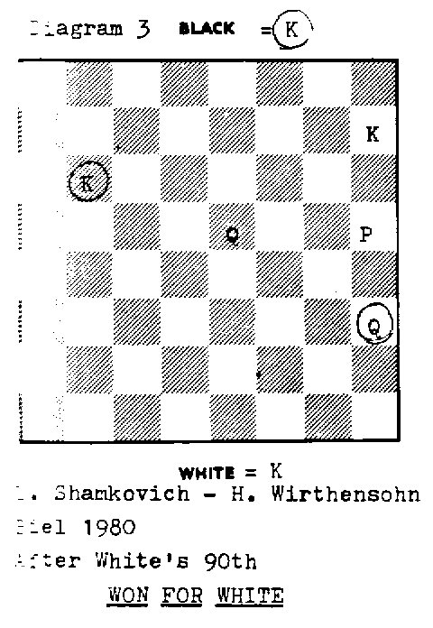
Diagram 3
Finally White gets the right idea of maximizing his Queen power.
White’s powerfully centralized Queen (possible only because Black on his previous move neglected to do the same with his Queen’s Black's randomly placed Queen and poorly placed King add up to a won position for White.
From now on White's task is relatively easy and he strays no more.
90 …Qd7+ , 91 Kg6 Qd3+ , 92 Qf5 Qg3+ , 93 Kf7 Qc7+, 94 Kg8 Qb8+ ,
95 Kg7 Qc7+, 96 Qf7 Qh2,

Black's checks are at an end and White can start advancing his pawn in safety and comfort.
97 h6 Ka5,
This attempt to improve his King position comes much too late.
98 h7 Qe5+, 99 Qf6 Qg3+, 100 Kh6! Black resigns.
After 100...Qh2+, 101 Kg6! any check by Black is answered by a countercheck..
To summarize: in this endgame a total of seven very serious errors were committed. Shamkovich does not query a single one of them, whereas Benko speaks of "GM Shamkovich's convincing performance".
I mention this only because it shows the great handicap that humans have in
analyzing this endgame.
a comparison of my 1981 analysis with BELLE’s results shows that I too committed a number of errors.

Endgame 2; J. C.van der Wiel-J.Federowicz, Graz 1981,after Black's 65th move.

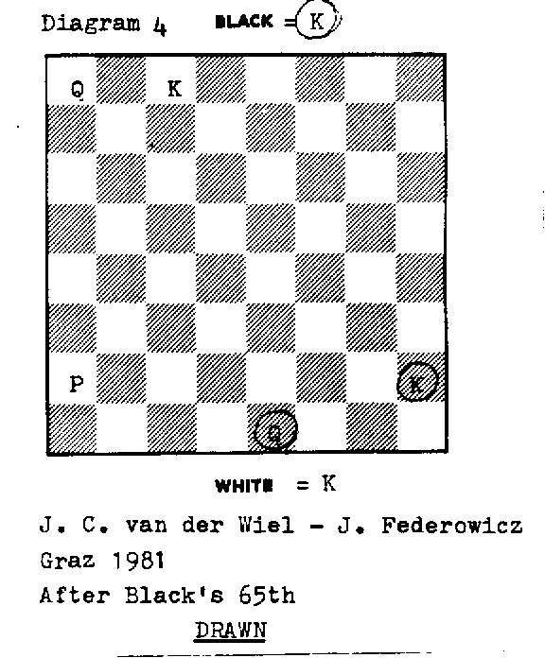
Diagram 4
This position is unquestionably drawn. Black's King is in the ideal far corner and White's pawn is still on the second rank.
Of course, the pawn can not be prevented from advancing.
However, Black has plenty of time to establish a correct King + Queen formation.
As long as Black's King remains in the far corner, he is sure of having a theoretical draw.
According to BELLE, Black's play is "perfect" - in the sense that he never allows White to have a theoretically won position.
66 Qd5 Qc 3+, 67 Kd7 Qg7+, 68 Kc6 Qc3+, 69 Kb5 Qb2+
70 Kc5 Qa3+ , 71 Kd4 Pa7+, 72 Kd3 Qa3+, 73 Ke2 Qe7+,
74 Kd1 Qa3, 75 Qc4 Qd6+ , 76 Kc2 Qg6+, 77 Qd3 Qc6+,
78 Kd1 Qa8, 79 a3 Kg2 , 80 Kc2 Kf2?!,
Black's outstanding active Queen play has kept White's progress to a minimum:
the a-pawn has moved forward just one square.
But by moving his King towards the center he needlessly exposes himself
to nasty counterchecks. The thematic 80...Kh2! is simplest and best.

81 Qd4+ Kf3,
81...Kg2! is better. The text is based on a "naive" Queen exchange hope.
82 a4 Qe4+, 83 Kc3! Qc6+, 84 Qc4 Qf6+, 85 Kb3 Qb6+, 86 Qb5 Qe3+,
87 Kc4 Qe4+, 88 Kc5 Qe5+, 89 Kc6 Qe6+, 90 Kc7 Qe7+, 91 Qd7 Qe5+,

92 Kb7 Qb2+, 93 Qb5 Qg7+, 94 Ka6 Qg6+, 95 Ka7 Qg1+,

Since 95…Qg7+?? allows 96 Qb7+, Black is about out of checks.
96 Qb6 Qa1, 97 a5 Ke2, 98 Qe6+ Kf1, 99 Qf5+ Ke1?!,

It has become clear that Black is not really sure how he should play his King.
As van der Wiel suggests, the best direction is 99...Kg1! followed by Kh2.
The new time control and prospective adjournment is after Move 104 and thus Black soon is able to replenish the necessary knowledge.

100 Kb6 Qb2+, 101 Kc6 Qc3+, 102 Kd6 Qb4+, 103 Qc5 Qb8+,
104 Ke7 Qb7+, 105 Kf6 Qf3+, 106 Qf5 Qa8, 107 Qe6 Kf1, 108 a6 Kg1!,

Diagram 5
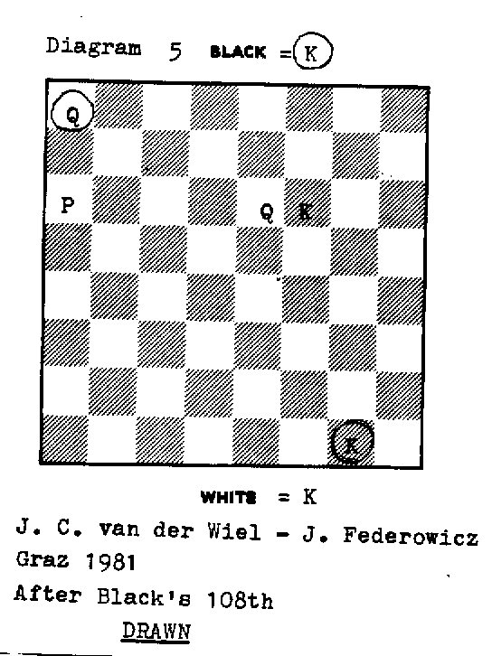
Black plays his King to the right place and strays no more.
It was this position that I specifically asked BELLE to evaluate.
It confirmed my evaluation that it is drawn and added that it remained drawn throughout the coming play.
Van der Wiel now suggests 109 Kg7!? as a better practical try.
109 Qb6+ Kh2! , 110 Oc7+ Kg1!, 111 Qc5+ Kh2, 112 a7

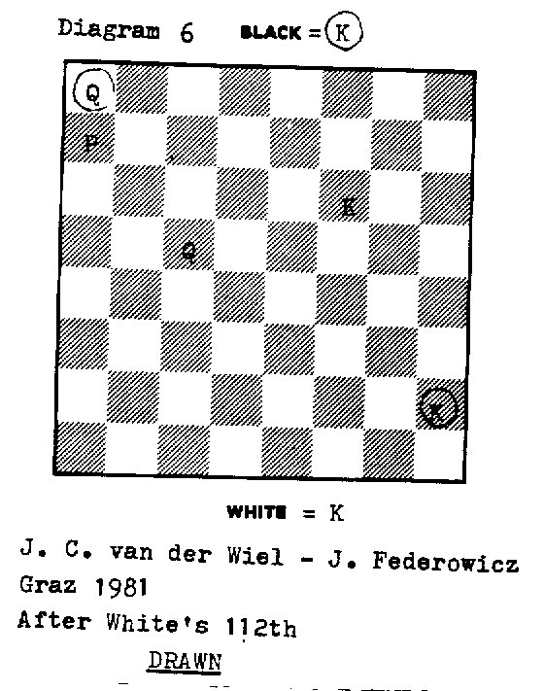
Diagram 6
An instructive and important position, deserving its own diagram.
White's Queen is not at all badly placed. Yet Black's King is out of the way and Black's Queen can start a checking sequence from a sufficiently flexible square.
Therefore the position is drawn.
112 …Qh8+, 113 Kg5 Qg7+, 114 Kf5 Qh7+, 115 Kf4 Qf7+,
116 Ke3 Qb3+, 117 Ke4 Qb7+, 118 Kd3 Qa6+, 119 Ke3 Qe6+,
120 Kd4 Qg4+,

Black must check on an active and flexible square, thus giving him a choice of "good" follow-up checks. Moreover, Black wants to have White's Queen remain on c5, rather than allow it to improve its position to d4.
121 Kc3 Qf3+, 122 Kd2 Qg2+!, 123 Ke1 Qe4+, 124 Kd1 Qf3+,
125 Kc1 Qh1 +!, 126 Kb2 Qb7+!, 127 Ka3 Qf3+ , 128 Kb4 Qe4+,
129 Kb5 Qe2+, 130 Kc6 Qe8+, 131 Kb6 Qe6+, 132 Kb7 Qe4+,
133 Kc7 Qh7+, 134 Kc6 Qe4+, 135 Qd5

Generally such a centralization is in White's interest, but here Black's Queen can remain sufficiently active for the perpetual. Moreover, an obvious disadvantage of the text is that the Queen no longer protects the pawn.
135 ...Qa4+, 136 Kb7 Qb4+, 137 Kc7 Qe7+ , 138 Qd7

This deactivation of the Queen can not bring results, but there is also nothing in 138 Kb8 Qf8+ etc.
138 ...Qc 5+, 139 Kb8 Qf8+, 140 Qc8 Qb4+, 141 Ka8 Kg1!,

With White's King blocking his pawn all that Black needs to do is to make sure that he does not allow decisive checks on b7 or b8.

142 Qc1+ Kf2, 143 Qb2+ Qxb2, Draw
At the end of such a marathon, White allows himself the small joke of stalemate.

CONCLUSIONS
We have learned which of many important specific thematic positions are won and which are drawn and why.
Thus our over-all theoretical knowledge has been considerably advanced. However, rigorous generalizations are still difficult to come up with. It is of course exactly this kind of information which is most important for the practical players.
Therefore, I am presenting some preliminary general principles.
For the case where White has the h-pawn:

Principles To draw
(A) King Play
(1) By far the safest and best area for the defensive King to be in is the far corner, i.e. the a1- a3 - c3 - c1square. Whithin this area, the preferred square is a1 - a3 - b3 – b1.
Regarding which individual square is best: this depends on the situation of the other pieces. Your King should be on such a square that it does not hinder checks by your Queen which are required to prevent the pawn from queening.
(2) For the specific case where the enemy Queen is centralized and the enemy
King will try to escape from checks by heading is towards the defending King, probably the best location for the defending King is b3.
(3) Once the defensive King is in the far corner, it should remain there.
(4) At certain moments the King can also be on many other squares with the position still drawn. This is true for at least the following squares: b6, c7, c8, c6, d7, d6, d3, e3, f3, f2, e4.
However, it is much more difficult to correctly handle such position!

(B) Queen Play
(1) The most powerfully placed Queen is the central one.
A centralized Queen (e.g. on d5) can be powerful enough to draw even if your
King is not in the far corner.
(2) Check on the central squares as this gives more flexibility for follow-up moves.
(3) Once you have started checking with an active, centrally placed Queen in
a situation where the enemy Queen is passive or relatively passive, check in
such a manner that the enemy Queen can not be recentralized.
(4) Use your Queen to keep the enemy King contained in front of his pawn.
(5) Use your Queen to prevent the activation of the enemy Queen.
For example, if the enemy Queen is inactive on the edge of the board on h5,
it is wrong to allow it to improve its location to f7.
(6) If your Queen is centralized on e5, it will draw against the pawn on h7
and Queen on g6 or f7 if your King is in the far corner.
- If your Queen is actively placed for checking and your King is in the far corner,
the position is drawn even if the enemy Queen is on f5 and the pawn on h7.
- Keep your Queen actively and flexibly placed. As a general principle it will be
better placed on the more active c2 square than the passive h7 square.
- However, the location on h7 is often good enough to draw.
The exceptions generally are where the enemy King can approach the pawn
from behind, i.e. d8 and e8 .

Principles To Win
(A) King Play.
(1) The worst position for the King is in front of the pawn.
(2) There generally are two good locations for the King:
(a) In a safe location to the side of the pawn, e.g. f7, f8, e8.
Often these squares are reached by sneaking in around the Queenside.
(b) Close to the enemy King. This gives opportunities for many counterchecks.

(B) Queen Play
(1) A centralized Queen is very powerful.
(2) Keep your Queen as active as possible. For instance:
(a) On f6 it is better placed than on g5
(b) On g5 it is better placed than on g7
(c) On f4 it is better placed than on h4
- Only advance the pawn to the 7th rank if your Queen is placed well
enough to prevent perpetual check.
- With a pawn on h7, the best location for the Queen is e4.
However, in favorable situations, other locations (e.g. f5, d7) will also win.

Important notice in regard to the above principles;
Remember that these are for the thinking human player.
They are not an automatic formula.
Use your head to make sure that there is not some unexpected exception in your case!

SPECIFIC REFERENCES
Game # 1; L. Shamkovich - H. Wirthensohn. Biel 1980
1. Chess Informant # 30, Endings 3 (L. Shamkovich)
2. Chess Life, April 1982, p. 45 (P. Benko)
Game # 2; J. C. van der Wiel - J. Federowicz. Graz 1981
1 . Chess Informant # 32, Game 264 (J. C. van der Wiel)
Finali di Donna e Pedone di Torre contro Donna:
teoria consolidata e sviluppi recenti.

di Edmar Mednis
(Libera traduzione di Mattia Antonetti)

In un articolo pubblicato nel numero di Febbraio-Marzo 1981 della rivista CHESS, ho discusso gli importanti sviluppi di quel periodo riguardo al finale di Donna e Pedone di Torre contro Donna.
Tra tutti i finali di Donna e Pedone contro Donna, il caso del Pedone di Torre è il più importante per il giocatore di torneo perché è quello che si verifica più spesso, e il motivo di ciò è altrettanto comprensibile: le probabilità che il Pedone di Torre sia stato cambiato nelle fasi di gioco precedenti sono inferiori rispetto a quelle di tutti gli altri Pedoni.
Nell'articolo di cui sopra avevo insistito affinché il compito di analizzare il finale di Donna e Pedone contro Donna fosse affidato ad un importante programma di scacchi per computer.
Il piccolo numero di pezzi rimasti sulla scacchiera fa sì che questo finale sia perfettamente analizzabile per i programmi con molta "forza bruta", e allo stesso tempo il tedio estremo che caratterizza questo tipo di finali li rende piuttosto ostici a un analista umano.
Nel 1985 il mio desiderio fu esaudito: il programma di scacchi BELLE, che era stato campione del mondo dei programmi, quell'anno passò gran parte del suo tempo intraprendendo uno studio esauriente di questo finale.
Durante questo processo, BELLE generò una vera montagna di informazioni. Sfortunatamente però, ogni tentativo di affrontarla sarebbe tuttora un compito difficilissimo per un umano, proprio a causa delle sue enormi dimensioni.
Avendo già pubblicato del materiale sul finale di Donna e Pedone di Torre contro Donna, ho deciso di sfruttare la "perizia" e la capacità di calcolo di BELLE in questo campo.
Ho selezionato dai tornei più recenti i sei finali a mio parere più importanti dal punto di vista teorico e ho chiesto a BELLE di commentarli, fornendo in questo modo valutazioni ed analisi a noi umani.

Questo articolo è basato sui risultati del lavoro di BELLE.
Mi sento in dovere di rivolgere un enorme ringraziamento a Ken Thompson, la "mente" principale che ha realizzato il programma BELLE, e al Maestro Internazionale Mike Valvo, per il loro aiuto e la cooperazione dimostrata accontentandomi nella mia richiesta e illustrandomi il "pensiero" di BELLE.
Un aspetto importante di ciò è il fatto che, grazie al suo lavoro del 1985, BELLE ha sviluppato un grande database di posizioni vinte e patte. Dal momento che crede sia giusto giocare a scacchi in modo "obiettivo", BELLE si rifiuta di giocare per vincere nelle posizioni che, secondo il programma, sono patte teoriche. Per questa ragione non siamo in grado di capire quali siano i tentativi più efficaci per cercare di vincere in posizioni simili.
Il mio metodo sarà quello di presentare i finali così come li vede BELLE. Spiegherò perché le mosse giocate sono buone o cattive e confronterò le conclusioni di BELLE con quelle di alcuni noti analisti umani.
Come vedremo, gli umani sbagliano spesso: il motivo è che (come ho già indicato) questo è il finale per noi più difficile da analizzare.
In questa presentazione è implicita la mia convinzione che non c'è motivo di dubitare delle analisi di BELLE. Discuterò qui soltanto due dei finali: prima quello in cui gli umani hanno giocato peggio, quindi quello giocato meglio.
Infine riassumerò i risultati più importanti tratti dallo studio di tutti e sei i finali.
Finale n°1: L. Shamkovich - H.Wirthensohn, Biel 1980, dopo la 77° mossa del B.

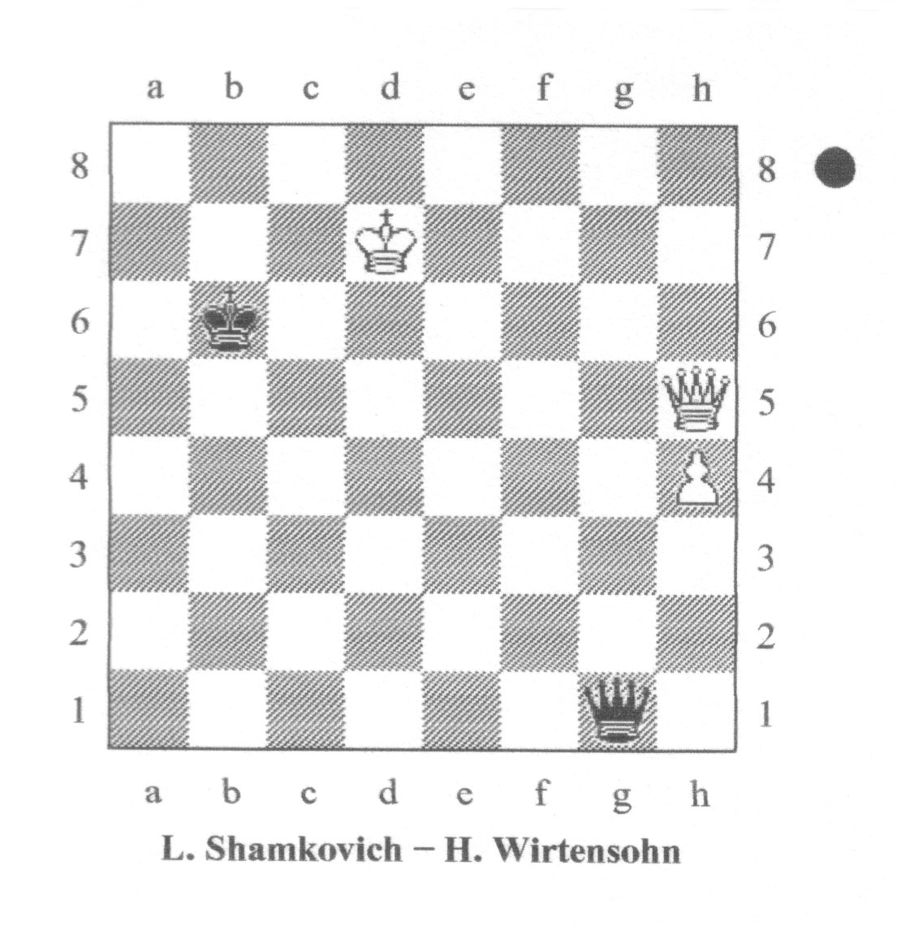
Diagramma 1
Biel 1980 Dopo la 77a mossa del Bianco PATTA
Il Bianco ha appena catturato il pedone h del Nero: abbiamo così raggiunto il genere di posizione di finale importantissima nel gioco pratico.
Questa posizione è una patta teorica.
Il Nero, comprensibilmente, non sa bene come procedere, e così inizia a dare scacco:
77 ... Dg7+, 78 Re6 Dg8+, 79 Re7 Dg7+?,

I primi due scacchi del Nero erano buoni, ma il terzo è un grave errore poiché, continuando automaticamente a dare scacco, il Nero permette al Bianco di migliorare considerevolmente la posizione della sua Donna. Sia 79 ... Dg3 che 79 ... Dc4 erano corrette (e la posizione sarebbe rimasta patta), in quanto tutte e due avrebbero impedito al Bianco di migliorare sensibilmente la posizione della Donna.

80 Df7!

Da qui la Donna protegge bene il Re (80 ... De5+?, l'unico scacco ragionevole, viene confutato da 81 De6+) e inoltre controlla più case, essendo ora più centralizzata che
non in h5.
80... Dg3,

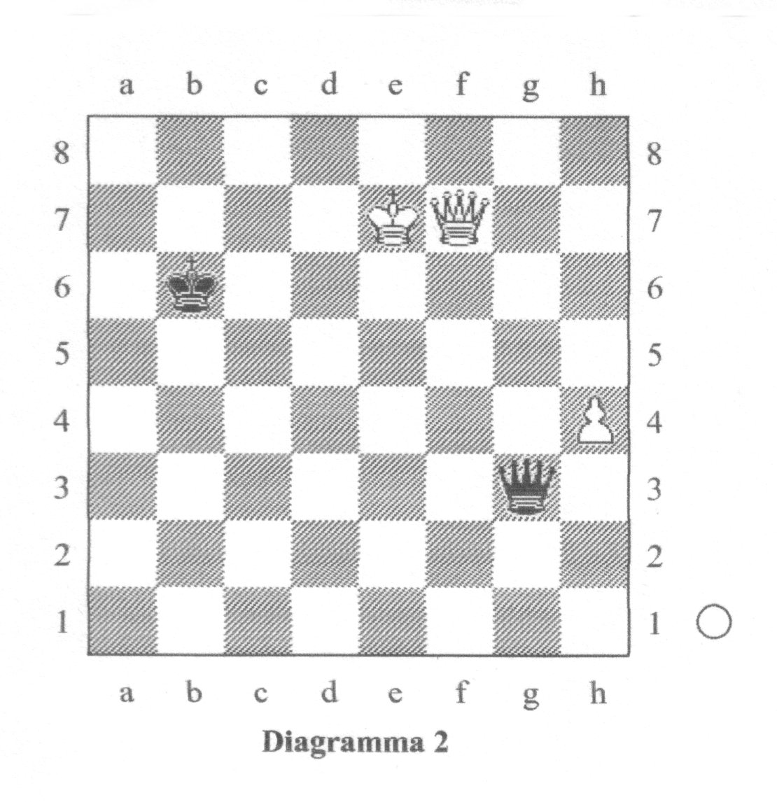
Diagramma 2

Biel 1980 Dopo la 80a mossa del Nero VINTA PER IL BIANCO
Questa è una posizione molto importante dal punto di vista teorico, perché è vinta per il Bianco. Notate che si giunge a questa conclusione mentre il pedone è ancora sulla quarta traversa. Questa è la posizione che ho fatto analizzare a BELLE, chiamandola a ragione "vinta per il Bianco".

81 Df6+

Il GM Benko ha indicato che il Bianco avrebbe potuto giocare subito 81 h5, visto che ben presto il Nero non avrà più scacchi: 81 ... Da3+ (81 ... Dh4+?, 81 ... Dg5+?, 81 ... De3+? e 81 ... De5+? sono tutte controbattute da un immediato contro scacco.)
82 Rf6 Dc3+ 83 Rg6 Dd3+ 84 Rg7.
È importante notare quanto sia ben piazzata la Donna bianca in f7.
Comunque, BELLE non ha problemi con la mossa del testo, dal momento che mantiene in pugno la vittoria.
81... Rc7, 82 Dg5??

Sia Benko che Shamkovic attribuiscono a questa mossa un punto esclamativo, ma in realtà si tratta di una mossa ridicola.
In f6 la Donna ha un raggio d'azione maggiore che non in g5 e pertanto non deve essere disattivata a meno che non ci sia una vittoria forzata.
Nel nostro caso, la vittoria non c'è.
La posizione è ancora vinta sia dopo 82 Rf7 che dopo 82 Rf8 oppure 82 Re8.
Tutte queste mosse lasciano libera la casa e7 per un contro scacco di Donna potenzialmente vincente. Comunque, la mossa più forte è 82 h5! subito.
Secondo BELLE le mosse che seguono rappresentano la continuazione migliore
per entrambi i giocatori:
82 ... Da3+, 83 Rf7 Da2+, 84 Rg7 Dg2+, 85 Dg6 Db2+,
86 Rh7 Db3, 87 h6 Rd7, 88 Df5+ Rd8, 89 Df8+ Rd7,
90 Rh8 Rc6, 91 De8+ Rc5, 92 De5+ Rc6 , 93 Rg7 Db7+,
94 Rf6 Db1, 95 De8+ Rc5, 96 Dh5+ Rc4, 97 h7 Db6+,
98 Rg7 Dd4+, 99 Rh6 Dd6+, 100 Dg6 Dh2+, 1 01 Rg7 Db2+,
102 Df6 Dg2+, 103 Rh6 Dh1+, 104 Rg6 Dg2+, 105 Dg5 Dc6+,
106 Rg7 Dd7+, 107 Rh6 Dh3+, 108 Rg6 De6+, 109 Df6 Dg4+,
110 Rf7 Dd7+, 111 Rg8 Dg4+, 112 Rf8 Dc8+, 113 Rg7 Dg4+,
114 Dg6 Dd4+, 115 Rf8 Dd8+, 116 De8 Dd6+ , 117 De7 Dh6+,
118 Re8 Dc6+, 119 Dd7 Da8+, 120 Re7 Da3+, 121 Rd8 Df8+,
122 Rc7 Dh8, 123 Df5 Rb3, 124 Rd7 Dd4+, 125 Re7 Dc3,
126 De6+ Rc2, 127 Rf7 Dc7+, 128 Rg6 Dg3+, 129 Rf6 Dc3+,
130 Rg5 Dg3+, 131 Dg4 De3+, 132 Rf6 Db6+, 133 De6 Dd4+,
134 Rg6 Rd1, 135 Rf7 Da7+, 136 De7 Dd4, 137 Dc7 Dd5+,
138 Re8 De4+, 139 De7 Dg6+, 140 Rd8 Db6+, 141 Dc7 Df6+,
142 Rc8 Da6+, 143 Db7 Dc4+, 144 Rd8 Dh4+, 145 De7 Dh5,
146 Rc8 Rc2, 147 Rb8 Dh3, 148 Dg7 Db3+, 149 Db7 Dh3,
150 Dc8+

Da questa sequenza si possono trarre due conclusioni:
(1) È incredibilmente difficile per un umano riuscire a trovare la continuazione migliore.
- Sono necessarie più di 50 mosse per vincere a partire dal momento in cui il
pedone raggiunge la settima traversa.
- Pertanto, è necessario che la FIDE cambi la regola delle 50 mosse per
questi finali.
Devo aggiungere che è ben noto alla teoria dei finali come spesso portare il pedone in h7 sia molto più facile che portarlo in h8.
Il metodo di vittoria generalmente richiede queste due cose:
(1) Forzare la Donna del difensore nella casa passiva h8 (24 mosse nel nostro caso).
- Il giocatore in vantaggio deve migliorare la coordinazione e il posizionamento del Re e della Donna in modo tale da poter soffocare il contro gioco avversario (questo ha richiesto altre 27 mosse).
82 ... Da3+, 83 Rf7 Db3+, 84 Rg7 Dc3+?,

Uno scacco debole, che porta di nuovo ad una posizione persa.
In questa casa la Donna non ha abbastanza libertà di movimento, in quanto il suo Re le impedisce l'accesso ad alcune case da cui sarebbe potenzialmente in grado di dare scacco. Dopo la più elastica 84 ... Db2+ la posizione resterebbe patta.

85 Df6 Dg3+, 86 Rh7??

Sebbene questa mossa sia stata ignorata sia da Benko che da Shamkovic, si tratta veramente di una mossa "criminale". È ben noto come, con il pedone in h, la posizione peggiore per il Re sia davanti al pedone, in quanto ciò rende la sua avanzata molto difficoltosa. Adesso il finale è patto. La mossa migliore per vincere è 86 Rf8!, che evita ogni scacco e contemporaneamente porta il Re in una buona posizione.
Comunque per mantenere una posizione vinta è sufficiente anche 86 Rf7 e 86 Dg5.
86 ... Dh3, 87 Dg5 Rb6??,

Una mossa sfortunatissima, quando quasi tutte le altre (undici, per la precisione!) pattano. Il Nero può avvicinarsi con il Re (con 87 ... Rd6 e 87 ... Rd7), restare più o meno dove si trova (87 ... Rc6 o 87 ... Rc8), oppure effettuare qualunque mossa ragionevole con la Donna: 87 ... Df1, 87 ... Df3, 87 ... Dh2, 87 ... Dh1, 87 ... Da3, 87 ... Db3 e 87 ... Dd3+. In quest'ultimo caso Shamkovich si accontenta di indicare "88 Dg6 seguita da 89 h5", ma a quanto pare non si accorge che il suo Re è mal posizionato per poter eseguire una manovra vincente.
Benko va più vicino al bersaglio con la sua annotazione (?!) e commenta:
"È difficile dire se il Re nero si muove nella giusta direzione".
88 h5 Dd7+, 89 Dg7?

Il Bianco commette di nuovo il grave errore di spostare la Donna da una posizione più attiva (g5) ad una meno attiva.
Qualunque mossa legale di Re avrebbe vinto: 89 Rh6, 89 Rh8, 89 Rg6, 89 Rg8.
89 ... Dh3??,
La risposta del Nero è ancora peggiore. Portando a sua volta la Donna in una posizione meno attiva, egli regala di nuovo una posizione vinta al suo avversario. Avrebbe dovuto giocare la centralizzazione 89 ... Dd5!, abbastanza ovvia, e avremmo avuto di nuovo una patta teorica. 90 De5!,

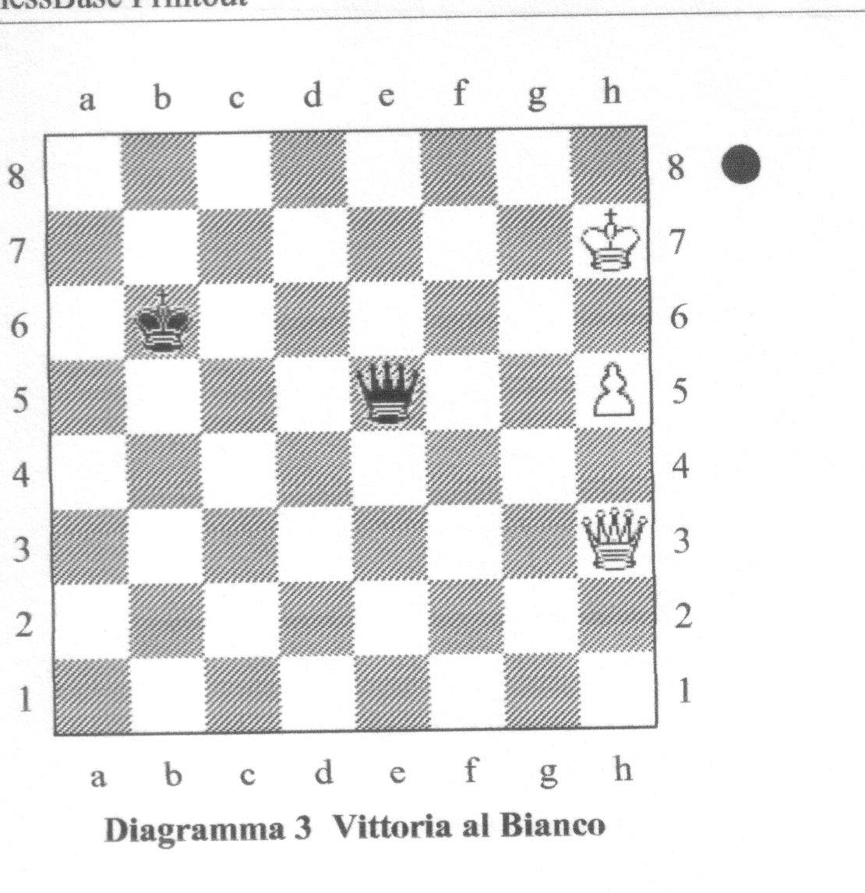
Diagramma 3

Biel 1980 Dopo la 90a mossa del Bianco VINTA PER IL BIANCO
Finalmente il Bianco ha l'idea giusta: massimizzare la potenza della Donna.
Ora la forte Donna bianca centralizzata (il che non sarebbe stato possibile se al tratto precedente il Nero non avesse dimenticato di fare lo stesso), la Donna nera posizionata a caso e il Re nero piazzato male danno al Bianco una posizione vinta.
D'ora in avanti il suo compito è relativamente facile, ed egli non commette più errori.
90 ... Dd7+, 91 Rg6 Dd3+, 92 Df5 Dg3+, 93 Rf7 Dc7+,

94 Rg8 Db8+, 95 Rg7 Dc7+, 96 Df7 Dh2,

Il Nero non ha più scacchi e il Bianco può comodamente iniziare a spingere il pedone in tutta sicurezza. 97 h6 Ra5,
Questo tentativo di migliorare la posizione del Re arriva decisamente troppo tardi.
98 h7 De5+, 99 Df6 Dg3+, 100 Rh6! abbandona

Dopo 100 ... Dh2+, 101Rg6! qualunque scacco del Nero viene parato con contro scacco.
Ricapitolando: in questo finale sono stati commessi in totale sette errori molto gravi. Shamkovich non ne segnala neppure uno, e Benko parla di "prestazione convincente da parte del GM Shamkovich".
Riporto questo commento soltanto perché esso dimostra il grosso handicap degli umani
nell'analizzare questo finale. Un confronto della mia analisi del 1981 con i risultati di BELLE mostra che anch'io ho commesso un gran numero di errori.

Finale n°2: J.C. van der Wiel - J. Federowicz, Graz 1981, dopo la 65a del Nero.

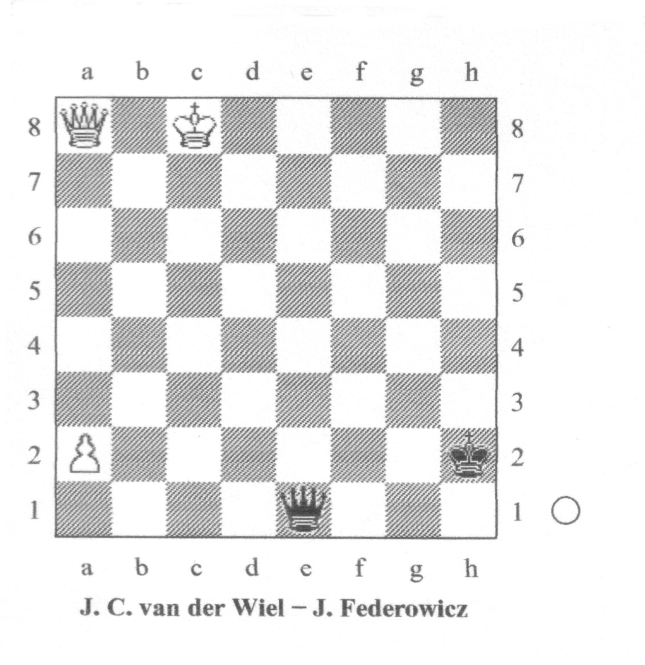
Diagramma 4
Graz 1981 Dopo la 65a mossa del Nero PATTA
Questa posizione è indiscutibilmente patta. Il Re nero si trova nell'angolo ideale, quello lontano, e il pedone bianco è ancora alla seconda traversa.
Naturalmente non è possibile impedire che questo pedone avanzi; però il Nero ha tutto il tempo di stabilire una corretta formazione di Re e Donna.
Finché il Re nero resta nell'angolo lontano, la patta teorica è assicurata.
Secondo BELLE, il Nero ha giocato in modo "perfetto" (nel senso che non ha mai lasciato il Bianco in posizione teoricamente vinta).
66 Dd5 Dc3+, 67 Rd7 Dg7+, 68 Rc6 Dc3+, 69 Rb5 Db2+ ,
70 Rc5 Da3+, 71 Rd4 Da7+, 72 Rd3 Da3+, 73 Re2 De7+,
74 Rd1 Da3, 75 Dc4 Dd6+, 76 Rc2 Dg6+, 77 Dd3 Dc6+,

78 Rd1 Da8 , 79 a3 Rg2, 80 Rc2 Rf2?!,

Il gioco straordinariamente attivo della Donna nera ha arginato i progressi del Bianco limitando ad un solo passo l'avanzata del pedone in a.
Muovendo il Re verso il centro però, il Nero si espone inutilmente a dei contro scacchi fastidiosi. La tematica 80 ... Rh2! è la più semplice e la più forte.
81 Dd4+ Rf3,

81 ... Rg2! è migliore.
La mossa del testo si basa su l'"ingenua" speranza di cambiare le Donne.
82 a4 De4+, 83 Rc3! Dc6+, 84 Dc4 Df6+, 85 Rb3 Db6+, 86 Db5 De3+,
87 Rc4 De4+, 88 Rc5 De5+, 89 Rc6 De6+ , 90 Rc7 De7+, 91 Dd7 De5+,
92 Rb7 Db2+, 93 Db5 Dg7+, 94 Ra6 Dg6+, 95 Ra7 Dg1+,

Poiché 95 ...Dg7+?? permette al Bianco 96 Db7+, e il Nero è sul punto di finire gli scacchi.
96 Db6 Da1, 97 a5 Re2, 98 De6+ Rf1, 99 Df5+ Re1?!,

È ormai chiaro che il Nero non sa bene in che modo deve giocare il Re.
Come suggerisce van der Wiel, la direzione migliore è 99 ... Rg1! seguita da Rh2.
Il prossimo controllo del tempo e il probabile aggiornamento saranno alla mossa n. 104, e così il Nero potrà ben presto riordinare le idee.
100 Rb6 Db2+, 101 Rc6 Dc3+, 102 Rd6 Db4+, 103 Dc5 Db8+, 104 Re7 Db7+, 105 Rf6 Df3+, 106 Df5 Da8, 107 De6+ Rf1, 108 a6 Rg1!,

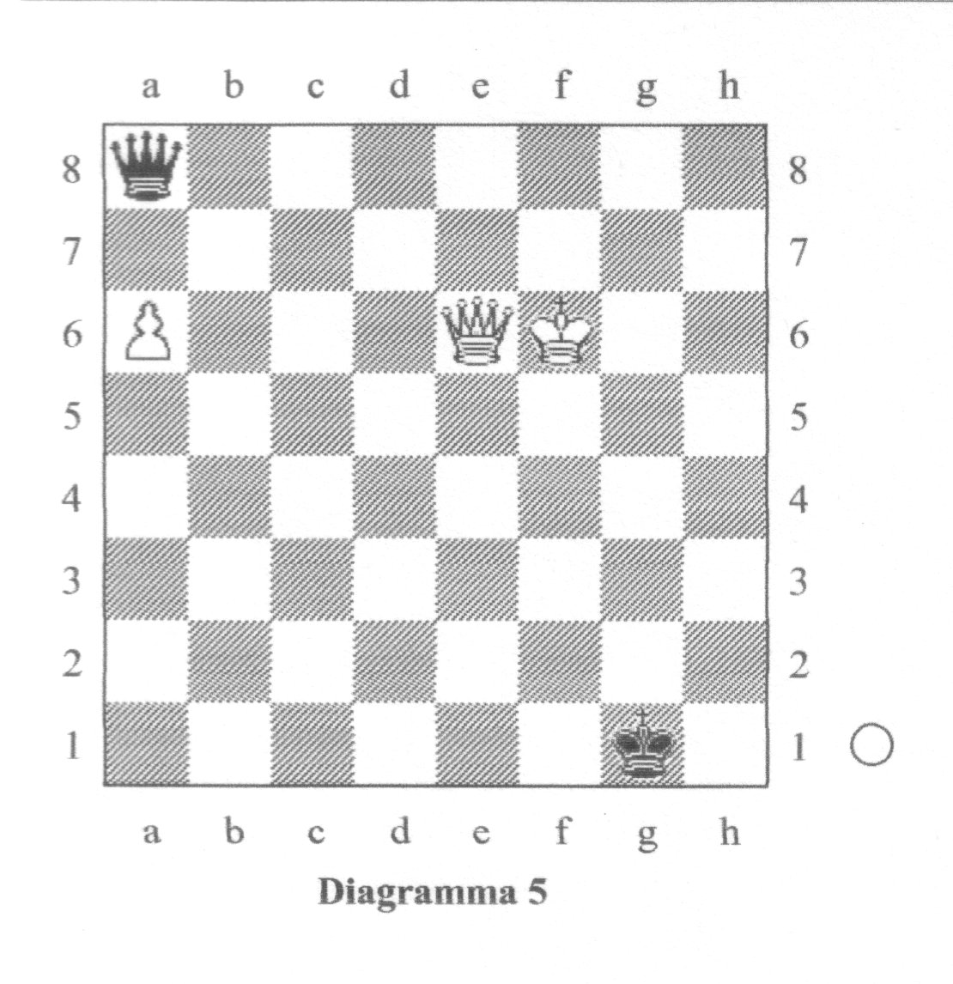
Diagramma 5
Graz 1981 Dopo la 108a mossa del Nero PATTA
Il Nero smette di sbagliare strada e porta il Re nel posto giusto.
Era questa la posizione che ho chiesto a BELLE di analizzare.
Il programma ha confermato la mia valutazione (patta) aggiungendo che la posizione è sempre rimasta patta per tutto l'arco delle giocate che seguono. A questo punto van der Wiel suggerisce 109 Rg7!? indicandola come un tentativo praticamente migliore.

109 Db6+ Rh2!, 110 Dc7+ Rg1!, 111 Dc5+ Rh2, 112 a7

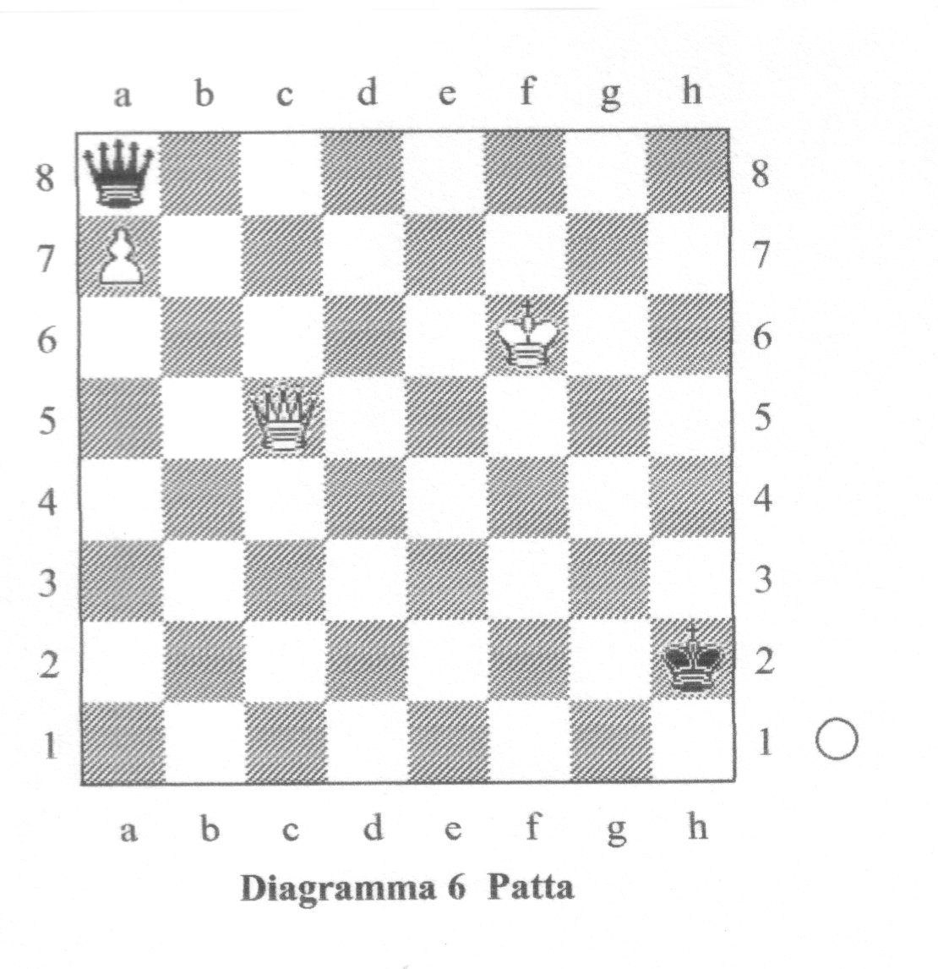
Diagramma 6
Graz 1981 Dopo la 112a mossa del Bianco PATTA
Una posizione istruttiva ed importante, che merita un diagramma.
La Donna bianca non è affatto mal posizionata; il Re nero però non intralcia la propria Donna, cosicché questa può dare il via a una serie di scacchi da una casa sufficientemente flessibile.
Pertanto la posizione è patta.
- ... Dh8+, 113 Rg5 Dg7+, 114 Rf5 Dh7+, 115 Rf4 Df7+, 116 Re3 Db3+,
- 117 Re4 Db7+, 118 Rd3 Da6+, 119 Re3 De6+, 120 Rd4 Dg4+,

Il Nero deve dare scacco da una casa attiva e flessibile, in modo da poter scegliere, alla mossa successiva, tra una serie di scacchi "buoni". Inoltre il Nero vuole che la Donna bianca resti in c5, e non che migliori la sua posizione portandosi in d4.
121 Rc3 Df3+ , 122 Rd2 Dg2+!, 123 Re1 De4+, 124 Rd1 Df3+,
125 Rc1 Dh1+!, 126 Rb2 Db7+!, 127 Ra3 Df3+, 128 Rb4 De4+,
129 Rb5 De2+, 130 Rc6 De8+, 131 Rb6 De6+, 132 Rb7 De4+,

133 Rc7 Dh7+, 134 Rc6 De4+ , 135 Dd5

Generalmente questo tipo di centralizzazione è nell'interesse del Bianco, ma in questo caso la Donna nera può mantenersi sufficientemente attiva per dare un perpetuo.
Inoltre questa mossa presenta un'ovvia controindicazione, dal momento che ora la
Donna non difende più il pedone.
135 ... Da4+, 136 Rb7 Db4+, 137 Rc7 De7+, 138 Dd7
La Donna ora è meno attiva, e questo non può portare a un buon risultato, ma non c'è niente neanche dopo 138 Rb8 Df8+ eccetera.
138 ... Dc5+, 139 Rb8 Df8+, 140 Dc8 Db4+, 141 Ra8 Rg1!,

Con il Re bianco a bloccare il pedone il Nero non deve far altro che evitare uno scacco risolutivo in b7 o b8.
142 Dc1+ Rf2, 143 Db2+ Dxb2, Patta

Alla fine di una maratona simile, il Bianco si concede lo scherzetto dello stallo.

CONCLUSIONI
Abbiamo imparato quali tra le tante importanti posizioni tematiche specifiche sono vinte e quali invece patte, e perché.
Quindi nel complesso la nostra conoscenza teorica ha fatto grandi passi avanti.
Resta comunque difficile fornire delle generalizzazioni che siano valide in tutti i casi, e naturalmente sono proprio queste le informazioni più importanti per i giocatori di torneo. Per questa ragione presenterò ora alcuni principi generali preliminari. Poniamo il caso che il Bianco abbia il pedone in h:

Metodi per pattare
(A) Come giocare il Re
- La zona migliore e più sicura per il Re in difesa è di gran lunga l'angolo lontano, cioè il quadrato a1 - a3 - c3 - c1. All'interno di quest'area, bisogna preferire le case comprese tra a1 - a3 - b3 - b1. La casa migliore in assoluto dipende dal posizionamento degli altri pezzi. Il vostro Re dovrà occupare una casa da cui non impedisca alla vostra Donna di dare gli scacchi necessari ad impedire la promozione del pedone.
- Nel caso specifico in cui la Donna nemica sia centralizzata e il Re nemico tenti di sfuggire agli scacchi dirigendosi verso il Re difensore, la posizione migliore per quest'ultimo è probabilmente in b3.
(3) Una volta raggiunto l'angolo lontano, il Re difensore non deve abbandonarlo.
(4) In determinati momenti il Re potrebbe anche essere in molte altre case e la
posizione sarebbe ugualmente patta. Questo è vero almeno per le case che
seguono: b6, c7, c8, c6, d7, d6, d3, e3, f3, f2, e4. Comunque questo tipo di
posizioni è molto più difficile da giocare correttamente.

(B) Come giocare la Donna
- La posizione migliore per la Donna è al centro. Una Donna centralizzata
(ad esempio in d5) può essere così forte da permettervi di pattare anche se il
vostro Re non si trova nell'angolo lontano.
- Cercate di dare scacco da una casa centrale: questo vi permette una maggiore
flessibilità nelle mosse successive.
- Una volta iniziata una serie di scacchi con la Donna attiva e centralizzata in una
situazione in cui la Donna nemica è passiva, almeno relativamente, date scacco
in maniera tale da impedire che la Donna nemica possa essere nuovamente
centralizzata.
(4) Usate la Donna per mantenere il Re nemico davanti al pedone.
(5) Usate la Donna per impedire a quella nemica di attivarsi.
Se per esempio la Donna nemica è inattiva sul bordo della scacchiera, poniamo
in h5, è sbagliato permetterle di migliorare la sua posizione portandosi in f7.
(6) Se la vostra Donna è centralizzata in e5, patterà contro il pedone in h7 e la Donna
in g6 o in f7 se il vostro Re è nell'angolo lontano.
(7) Se la vostra Donna è attivamente piazzata per dare scacco e il vostro Re è
nell'angolo lontano, la posizione è patta anche con la Donna nemica in f5 e il
pedone in h7.
(8) Tenete la Donna in una posizione attiva e flessibile. Generalmente è preferibile
posizionarla sulla casa attiva c2 piuttosto che sulla passiva h7.
(9) Ciò nonostante, la Donna in h7 spesso è sufficiente per pattare.
Le eccezioni sono di solito i casi in cui il Re nemico può avvicinarsi al pedone da
dietro, ossia da d8 ed e8.

Metodi per vincere
(A) Come giocare il Re
(1) La posizione peggiore per il Re è davanti al pedone.
(2) Generalmente ci sono due buone posizioni per il Re:
- In un posto sicuro dal lato del pedone, es. f7, f8, e8. Spesso queste case
vengono raggiunte passando dal lato di Donna.
(b) Vicino al Re nemico. Questo permette molte possibilità di contro scacco.

(B) Come giocare la Donna
(1) Una Donna centralizzata è molto forte.
(2) Tenete la Donna il più attiva possibile. Ad esempio:
(a) In f6 sta meglio che in g5
(b) In g5 sta meglio che in g7
(c) In f4 sta meglio che in h4
(3) Spingete il pedone in settima solo se avete la Donna abbastanza ben piazzata da
impedire lo scacco perpetuo.
- Con il pedone in h7, la posizione migliore per la Donna è in e4. Comunque,
in condizioni favorevoli si vince anche con la Donna in altre case(es. f5, d7).
Una considerazione importante riguardo ai metodi esposti:
Ricordate che questi sono destinati ad un giocatore umano pensante.
Non si tratta di una formula automatica: usate la testa per assicurarvi che nel vostro caso non ci sia qualche eccezione imprevista!

RIFERIMENTI SPECIFICI
Partita n°1: L. Shamkovich - H. Wirthensohn, Biel 1980
1. Chess Informant n° 30, Finali 3 (L. Shamkovich)
2. Chess Life, Aprile 1982, p. 45 (P. Benko) Partita n°2: J.C. van der Wiel - J. Federowicz, Graz 1981
- Chess informant n°32, Partita 264 (J.C. van der Wiel).

Il gioco degli scacchi nella formazione scolastica

Di Ettore Santi
1. Introduzione.
E' ben noto che dopo il Mille il gioco degli scacchi ebbe larga diffusione tra le classi nobili; cantato dai trovatori, era considerato una conoscenza indispensabile per il perfetto cavaliere. Monaci e frati lo utilizzarono per trame una serie di ammaestramenti e similitudini moraleggianti. ⁽¹⁾
Ma è soltanto nel nostro secolo che la funzione educativa del gioco degli scacchi è stata riconosciuta su basi scientifiche in particolare a seguito della ricerca degli psicologi russi Djakow , Petrowski e Rudik, i quali sottoposero 12 dei 21 partecipanti al torneo di Mosca del 1925 ad una serie di test psicologici riguardanti la memoria, l'attenzione, le funzioni combinatorie ed intellettuali e l'immaginazione.
A conclusione di tale ricerca pubblicarono un lavoro dal titolo "Psicologia del gioco degli scacchi" , tradotto in tedesco l'anno seguente.
Tale lavoro e la tesi di Adrian De Groot, ricercatore olandese, pubblicata nel 1946 e tradotta in inglese nel 1965 col titolo "Thought and Choice in Chess ", costituiscono importanti punti di riferimento bibliografico per individuare gli argomenti pedagogici a favore della diffusione del gioco degli scacchi in ambiente scolastico.
Più di recente le ricerche sull'intelligenza artificiale e la simulazione del pensiero col computer hanno fornito nuove indicazioni sia per l'utilizzo del gioco degli scacchi come supporto di problemi per l'insegnamento della matematica e dell'informatica sia per un suo utilizzo scientifico nei settori dell'intelligenza artificiale e della ricerca operativa.
Si è anzi sviluppata una branca della "Computer Science " chiamata "Computer Chess" . ( Si veda l'interessante articolo di rassegna [6] ).
In questa conversazione cercherò di mostrare , attraverso una adeguata esemplificazione, come il gioco degli scacchi possa costituire una miniera feconda di problemi e suggestioni per l'insegnamento della matematica ed anche come sia ipotizzabile, alla luce di esperienze recenti, un progetto scolastico autonomo sul gioco degli scacchi.

(1) Lo studioso strasburghese J.M.Mehl, nella sua tesi dottorale "Jeu d'Echecs et education au XIII siècle" ( Univ. de Sciences humaines de Strasbourg , 1979), ha studiato l'influenza pedagogica del gioco degli scacchi nella società medioevale.
2. Considerazioni sul valore educativo e formativo del gioco degli scacchi
La regola del gioco crea un ambiente spazio - temporale a tre dimensioni (due per lo spazio ed una per il tempo), nel quale si evolve una materia che rappresenta la lotta di due forze opposte ed equivalenti.
L'insieme delle regole è ispirato, in modo essenziale, ad un principio generale di uguaglianza, che mira a mantenere l'equilibrio posizionale tra i due campi e ciò non soltanto da un punto di vista spazio-temporale ma anche da un punto di vista strutturale e dinamico. L’esistenza di questo principio generale è ben evidenziabile studiando l'evoluzione delle regole. ⁽²⁾
Così l'aumento di potenza di alcuni pezzi (rispetto alle possibilità piuttosto modeste che gli stessi avevano in precedenza) è stato compensato introducendo la possibilità di mettere tempestivamente al riparo il re con l'arrocco (nella forma attuale), eliminando con ciò il pericolo che gli aspetti tattici e combinativi venissero a prendere il sopravvento su quelli posizionali.
Così ancora l'introduzione della spinta di due passi del pedone che si trova nella casa iniziale è stata compensata dalla introduzione della presa "en passant" .
Il problema generale che viene posto a ciascuno dei due giocatori nel corso di una partita è quello di cercare la vittoria laddove il risultato naturale della partita condotta correttamente è la patta a causa dell'uguaglianza iniziale e del principio generale di uguaglianza citato in precedenza.
E' qui la diversità del problema "ludico" rispetto ad un problema matematico.
La ricerca della "soluzione" in una partita (tra giocatori umani) non è esclusivamente di natura tecnica, poiché l'enormità del numero delle ramificazioni rende impossibile un calcolo esaustivo: si pensi che il numero delle varianti fino alla decima mossa (del nero) è dell'ordine di 10³⁰. Essa mette in moto vari processi del pensiero ed in modo particolare, come è stato evidenziato in [3] e [2], le funzioni mentali riguardanti la memoria, l'elaborazione e la decisione. (³⁾

E' da sottolineare il carattere dialettico dell'attività intellettuale dei due avversari: i due giocatori non possono certo ragionare in modo indipendente
Peraltro l'evoluzione del gioco non consiste in una semplice articolazione di stimoli e risposte riflesse ma comporta spesso l’elaborazione di nuove idee mediante un processo non dissimile a quello dell’artista.
(2) Per l'evoluzione delle regole del gioco si veda , ad esempio, [1] alla voce "Regole del gioco: Storia".
(3) Si veda anche [4] cap .I e II . spesso l'elaborazione di nuove idee mediante
E contemporaneamente la scoperta di elementi nuovi, non intravisti in precedenza, mantiene vivo il dubbio metodico, dando luogo a un vero metodo di pensiero.
De Groot così riassume il lavoro di analisi e ricerca che deve effettuare il giocatore: "Preparare un piano, raggruppare le alternative, approfondire progressivamente l'analisi, stabilire un ordine di investigazione, operare delle scelte, seguire le fasi del ragionamento scientifico." In effetti tra gli aspetti più salienti del lavoro di ricerca del giocatore possiamo sottolineare
-) l'analisi necessaria per impostare correttamente il problema
-) il calcolo necessario nell'esame delle varianti
-) l'elaborazione di una concezione generale della posizione sulla base di una
sintesi dei giudizi sulla posizione attuale e su quelle che ne discendono
-) il momento della decisione per operare la scelta tra le varie possibilità che
offre la posizione
-) la necessità di prova per dimostrare la validità di una decisione presa dopo
matura riflessione ma in un intervallo di tempo relativamente ristretto.
Queste considerazioni mettono in luce la ricchezza e la complessità dei processi che intervengono nella conduzione della partita e il carattere dialettico del ragionamento. E' qui che sta l'originalità del gioco degli scacchi dal punto di vista educativo e formativo
Né sono da trascurare i valori estetici offerti dal gioco nella ricerca della soluzione più breve ed elegante anziché di una soluzione qualsiasi.
Non si intende qui fare una apologia acritica del valore educativo del gioco degli scacchi e certamente è possibile sviluppare delle argomentazioni prudenziali, che non è qui possibile prendere in esame.
Per un esame complessivo della questione rinvio il lettore interessato a [8].

- Utilizzo del gioco degli scacchi come supporto di problemi nello studio della
matematica e dell'informatica
A meglio inquadrare 1'argomento che intendo presentare è opportuno premettere,
sia pure in modo informale, alcune idee sulla teoria del "Problem solving", rinviando a [9] per una più ampia conoscenza della teoria e dei metodi.
Un problema (formale) può essere pensato composto di tre insiemi di informazioni:
-) i dati iniziali,
-) l'obbiettivo finale,
-) le operazioni ammesse.

Una "soluzione di un problema" deve allora contenere,
-) la completa assegnazione dei dati iniziali, ciò che determina lo "stato
iniziale" del problema,
-) la conoscenza dell'obbiettivo,
-) la descrizione delle trasformazioni ammesse per passare da uno stato
del problema ad un altro,
-) un'ordinata sequenza di stati del problema che porti dallo stato iniziale ad uno
stato finale in cui è raggiunto l'obbiettivo.
Risulta efficace visualizzare le possibili sequenze di stati e di azioni mediante un grafo ad albero ("albero delle varianti ") in cui a ciascun nodo corrisponde uno stato del problema (peraltro a due o più nodi distinti può corrispondere uno stesso stato
del problema).

La figura 1 rappresenta una situazione in cui in ogni stato si hanno due possibili azioni alternative sicché al livello n (considerando come livello zero quello dello

stato iniziale) il numero dei nodi è 2^{n}.
Se in ogni stato possono aversi m azioni allora al livello n ci sono m^{n} nodi.

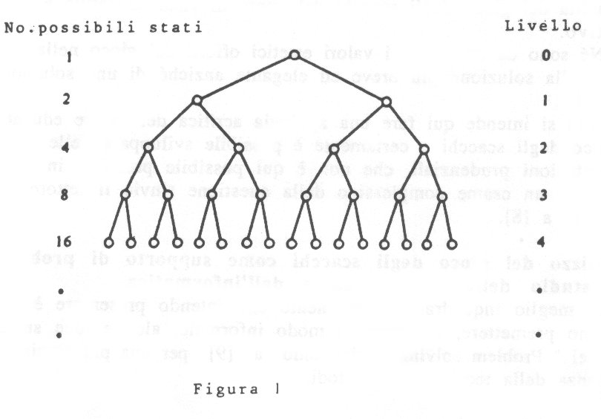
In generale il numero delle possibili azioni non è costante e quindi il numero dei rami che si dipartono dai nodi può variare da nodo a nodo.
Qualora il problema richieda (per la sua soluzione) una lunga sequenza di azioni per raggiungere l'obbiettivo si presenta la necessità di ridurre la mole del lavoro da effettuare, evitando di esaminare tutte le alternative (si parla di "potatura dell'albero delle varianti").

Naturalmente non è assicurata in generale la possibilità di potare l'albero.
Un'idea utile in relazione alla soluzione dei problemi ed, in particolare, alla potatura dell'albero delle varianti è quella di costruire delle funzioni di valutazione che assegnano un valore numerico reale (in molte situazioni un intero) ad ogni nodo.
In certi problemi che hanno opportune caratteristiche di ottimizzazione (si tratta cioè di massimizzare o minimizzare certe funzioni) si presenta la possibilità di pervenire alla soluzione spostandosi da un nodo ad un nodo immediatamente successivo in modo da avere il maggiore incremento possibile (in valore assoluto).
In altri casi la situazione non è così semplice ma è pur sempre possibile, raffinando le idee precedenti e introducendone di nuove, ottenere una efficace potatura dell'albero delle varianti.
La schematizzazione illustrata ben si adatta sia al problema generale della partita di scacchi (che è in effetti un problema di programmazione dinamica) sia a quasi tutti i problemi che utilizzano gli scacchi o anche soltanto la scacchiera che è uno spazio bidimensionale finito con 64 punti (le case).
Un esempio banale di una situazione in cui è facile costruire una funzione di valutazione "naturale" è il finale di Re e Torre contro Re.
Ad esempio, per fissare le idee, si abbia la posizione: Bianco: Re2, Ta1; Nero: Rd6.
Obbiettivo del Bianco è dare scaccomatto al Re nero nel minor numero di mosse possibile. Si può assumere come funzione naturale di valutazione (da minimizzare per il bianco e dualmente da massimizzare per il nero) il numero di case in cui si può rifugiare il Re nero, evitando naturalmente che questo numero sia zero (ciò che corrisponde alle posizioni di stallo).
Ed ecco ora un paio di esempi non banali, che W. Wickelgren utilizza in [9] per illustrare i meccanismi dei processi deduttivi.
Il primo costituisce parte di un problema di Sam Lloyd: nella posizione della figura 2
[ Bianco: Rf5, Pg2, Tg7; Nero: Rh5, Af2, Pg3, Ph6] Il Bianco muove e da matto in 5.
II punto rimarchevole è che si può formulare una ragionevole congettura relativa alle proprietà dell'obbiettivo, che facilita notevolmente la ricerca della soluzione.

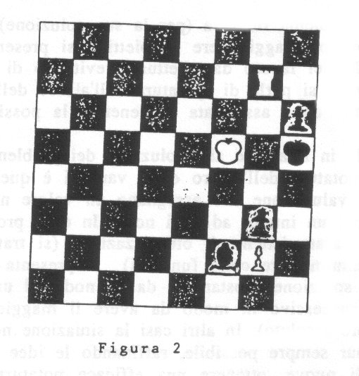
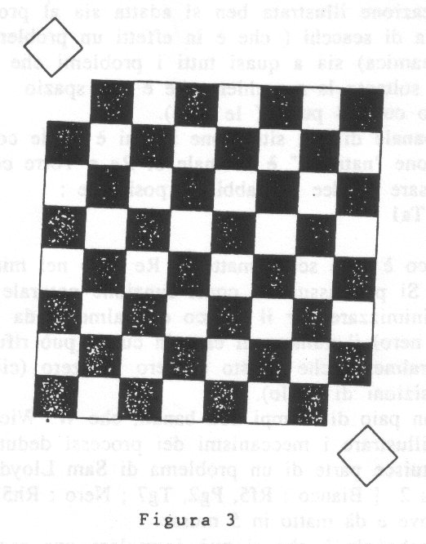
La congettura è che nello stato finale, cioè nella posizione di scacco matto, la torre bianca venga a trovarsi nella casa h1.
Il nero ha la possibilità di interporre il suo alfiere in due case della colonna h tra h1e il Re nero.
Si deve allora provare che sia l'uno che l'altro tentativo di difesa può venire frustrato pervenendo allo scacco matto nel numero di mosse indicato.
Naturalmente, se così non fosse, la congettura si rivelerebbe errata ed occorrerebbe ricominciare da capo, come spesso si verifica nell’approccio ad un problema scientifico.
Ed ecco ora un problema che utilizza la scacchiera senza i pezzi.
Si ha una scacchiera e delle tavolette rettangolari uguali ciascuna delle quali può ricoprire esattamente due case adiacenti della scacchiera.
Quindi con 32 tavolette si possono ricoprire le 64 case della scacchiera. Supponiamo ora di eliminare le due case a1e h8 oppure le case h1ed a8
(vedi Figura 3 ).
E' possibile con 31 tavolette ricoprire esattamente le rimanenti 62 case ?
Se sì, mostrare una soluzione. Se no, provare che ciò è impossibile.
Questo problema coinvolge in modo essenziale il metodo di deduzione per esplicitare certe proprietà della scacchiera e delle tavolette che sono per ora solo implicite.
La proprietà critica è che una qualunque tavoletta ricopre due case adiacenti della scacchiera sulla stessa riga oppure sulla stessa colonna. Ora due case adiacenti sono sempre l'una bianca e l'altra nera mentre le due case a1e h8 sono dello stesso colore e così pure le h1 e a8. La risposte al problema è ormai ovvia.
E' interessante osservare che se le case della scacchiera fossero tutte bianche l'espediente della coloratura (virtuale) delle case potrebbe costituire il primo passo per arrivare alla soluzione.
L'idea della coloratura delle case può peraltro venire facilmente sostituita da un'argomentazione "più matematica", numerando in modo progressivo le colonne da 1 a 8 oppure da 0 a 7 (vedi Figura 4), associando ad ogni casa una coppia ordinata (i,j) ove i è il numero d'ordine della riga e j della colonna e ragionando sulla somma i+j delle coordinate. Non ci dilunghiamo su ciò.
Sono possibili vari approfondimenti: innanzitutto il problema può essere
generalizzato al caso di una scacchiera NxN; si può poi rilevare che né le dimensioni

né (entro certi limiti) la forma hanno reale importanza ossia le proprietà essenziali del problema sono, per dirla coi matematici, di tipo topologico.
Ed ecco ora un elenco sommario di argomenti di matematica e di questioni scacchistiche che possono venire associate ai medesimi.
a) Aritmetica
- le operazioni elementari: valore dei pezzi, bilancio materiale, controllo delle case
- il tema della parità: problemi legati al movimento del cavallo
- proprietà aritmetiche della copertura della scacchiera da parte del cavallo
- progressioni geometriche: il problema leggendario di Sissa
b) Algebra e Geometria
- rappresentazione algebrica della scacchiera e notazione delle mosse
- simmetrie, rotazioni, gruppi: il problema delle otto regine e il problema
analogo per le torri,
- relazioni metriche
c) Calcolo combinatorio e calcolo delle probabilità
- permutazioni: il problema delle regine
- temi vari (Si veda la conferenza del Prof. Magari )
d) Informatica
- albero delle varianti
- traduzione in algoritmi di problemi scacchistici: il problema delle otto regine,
il problema del cavallo, il problema di Wythoff.
Alcuni dei problemi citati sono ormai classici.
Quasi tutti conoscono la leggenda di Sissa, il leggendario inventore degli scacchi, il quale avrebbe chiesto al re come ricompensa per la sua invenzione un chicco di grano per la prima casa della scacchiera, due per la seconda, 4 per la terza, 8 per la quarta e così via sempre raddoppiando per un totale di
1 + 2 + 4 +..... + 2⁶³ = 2⁰⁴-1
chicchi di grano non sarebbero bastati tutti i granai del regno per esaudire la richiesta!
Matematicamente assai più consistenti di questo sono altri problemi citati, di cui si occuparono matematici illustri come Eulero e Gauss. Vediamo in particolare

II problema delle otto regine pacifiche.
Il problema consiste nel collocare sulla scacchiera otto regine in modo tale che nessuna di esse minacci di presa un’altra. ⁽⁴⁾
Poiché è evidente che in ogni colonna dovrà trovarsi una ed una sola regina e così pure in ogni riga, si tratta di collocare l'una dopo l'altra le regine nelle colonne 1,2,...,8 facendo questo in tutti i modi possibili.
Esistono 92 soluzioni anche se in realtà il numero delle soluzioni da considerarsi "essenziali" è molto inferiore (sono dodici) e da queste si possono generare tutte le altre soluzioni mediante rotazioni e simmetrie assiali.
Questo problema che causò qualche difficoltà a un matematico del calibro di Gauss coinvolge (nella sua risoluzione) argomenti di calcolo combinatorio,
(permutazioni), di geometria (rotazioni, simmetrie), di algebra (gruppi, sottogruppi).
Se ne può considerare la generalizzazione al caso di una scacchiera con n righe ed n colonne in questi termini: collocare n oggetti in n case in modo tale che due qualunque di essi non stiano mai su una medesima riga né su una medesima colonna né su una medesima diagonale. (Per n<4 il problema non ha soluzione).
E’ interessante trattare questo problema con l’elaboratore mediante un algoritmo di ricerca ad esaurimento delle soluzioni. Lo schema dell'algoritmo sarà il seguente (7):
- collocare un pezzo nella prima riga della colonna 1
- passare alla colonna successiva cercando una casa utile (cominciando dal basso) in
cui piazzare legittimamente il pezzo; stampare la soluzione se il pezzo era l'ottavo
- iterare il procedimento: quando non è possibile alcuna collocazione del pezzo fare,
se possibile, un passo indietro per modificare la situazione che ci ha portati in un
vicolo cieco fino a sbloccare la situazione e riprendere poi il procedimento.
- Arrestarsi quando non c'è più modo di procedere.
Si possono così stampare tutte le 92 soluzioni del problema.
Ciò viene fatto indicando per ognuna gli indici di riga corrispondenti alle regine nelle colonne 1,2,...,8 ossia semplicemente mediante una permutazione della ottupla ordinata (1,2,3,4,5,6,7,8): per esempio (1,5,8,6,3,7,2,4), che nella stampa scriveremo semplicemente 5863724, significa che una regina sta nella prima riga della prima colonna (ossia in a1) una seconda regina sta nella riga 5 della seconda colonna (ossia in b5) eccetera.
4) Un problema analogo può essere posto per le torri. Entrambi i problemi sono trattati in maniera esaustiva nel libro di Kraitchik

L'algoritmo costituisce un'interessante illustrazione del metodo "backtrack" ossia di ritorno indietro a modificare scelte adottate in precedenza quando queste si rivelino prive di sbocco.
Si veda in Appendice, a titolo di curiosità, la traduzione dell'algoritmo in linguaggio GFA BASIC, implementato su elaboratore A tari ST, e la stampa delle 92 soluzioni. Un programma esteticamente assai più godibile si può preparare utilizzando la grafica ed un monitor a colori.
Numerose altre situazioni scacchistiche possono essere proficuamente utilizzate per costruire algoritmi per l'elaboratore; in particolare il problema di percorrere col cavallo tutte la case della scacchiera calpestandole una sola volta ciascuna,
(cfr [5] cap XI ) e il problema di strategia di Wythoff ( cfr. [7] cap. 3).
4. Alcune esperienze scolastiche
Si legge nel libro di Fine [4] che le accademie militari come West Point hanno accolto gli scacchi come materia obbligatoria, in quanto la strategia del gioco viene ritenuta simile alla strategia militare.
Non ho ulteriori informazioni su questo insegnamento nelle accademie.
Voglio invece accennare alle interessanti esperienze scolastiche che si sono avute in Francia e nella Svizzera francofona successivamente ed a seguito delle Olimpiadi scacchistiche di Nizza del 1974.
Il centro direttivo della sperimentazione è stata 1'Università Louis Pasteur di Strasburgo ove a partire dall'anno accademico 1975/76 è stato tenuto un corso complementare di insegnamento sul gioco degli scacchi, sotto la direzione del prof. Michel Roos, professore aggregato dell'Università e maestro di scacchi (ex campione di Francia).
Ecco il programma di massima del corso
1) 18 lezioni di 1 ora e mezza ciascuna così suddivise:
-9 lezioni su "Teoria e pratica del gioco degli scacchi"
-3 lezioni su "II mondo storico e culturale del gioco degli scacchi"
-6 lezioni su "II gioco degli scacchi come strumento di ricerca sui
temi: a) Psicologia e psicotecnica del gioco degli scacchi,
b) II gioco degli scacchi e l'informatica.
2) Esercitazioni complementari pratiche: una per settimana nel periodo delle
lezioni
Pressoché contemporaneamente all'attivazione di questo corso universitario, sono state sviluppate varie iniziative di inserimento del gioco degli scacchi tra le attività scolastiche complementari in alcune scuole secondarie di Strasburgo e di altre località dell'Alsazia.
Grazie all'appoggio determinante del ministero della pubblica istruzione francese e dello stesso presidente della repubblica francese Pompidou queste sperimentazioni si sono potute sviluppare con mezzi adeguati e con l'utilizzo di tutti i materiali didattici occorrenti (libri, scacchiere e pezzi, orologi, scacchiere murali, audiovisivi ecc.) ed hanno conosciuto un largo successo. Rimando per una migliore informazione a [8] ed alle successive relazioni del prof. Roos.
Analoghe sperimentazioni si sono avute a partire dall'anno scolastico 1976/77 nel Vallese svizzero sotto la direzione del maestro di scacchi rumeno Carlo Partos che ha anche preparato manuali per l'insegnamento degli scacchi e varie relazioni su queste esperienze scolastiche, che hanno interessato i distretti scolastici di Martigny, Orsières e Sion.

5. Prospettive scientifiche.
Qualunque materia di insegnamento, per essere credibile, deve essere anche argomento di ricerca.
Indichiamo qui i più significativi temi di ricerca scacchistica nell'ambito delle discipline più strettamente interessate.
- La letteratura e le arti: Studi sull'utilizzo di temi scacchistici in pittura, nel
cinema e soprattutto nella letteratura.
- Psicologia e processi del pensiero: Le ricerche di Djakow e soci e di De
Groot sono ben lungi dal risultare esaustive.
Le teorie psicoanalitiche di Fine sul giocatore di scacchi costituiscono
più un contributo alla discussione che una conclusione.
3 dell’evoluzione delle regole, dei pezzi .....
4. Matematica, informatica, cibernetica: Vari possono essere i temi a livello di
ricerca, ma certamente il più importante concerne la creazione di algoritmi per
la partita e su di esso ci soffermeremo qui.
Il numero enorme di ramificazioni dell'albero delle varianti crea la necessità di introdurre criteri per la potatura dell'albero, anche quando il giocatore umano viene sostituito da un potente computer.
Ad evidenziare la complessità della realizzazione di un programma di gioco per l'elaboratore indichiamo alcuni momenti del lavoro necessario:
-) Operare una descrizione matematica della regola del gioco e tradurla
in un algoritmo per l'elaboratore.
-) Costruire una (o più) funzioni di valutazione della "differenza di potenziale"
tra i bianchi ed i neri e tradurla in un algoritmo per l'elaboratore.
-) Utilizzare dati statistici per le aperture;
-) Determinazione di criteri che permettano di simulare il modo di pensare
umano ed il modo di operare scelte del maestro di scacchi.
-) Ricerca di algoritmi caratteristici per la condotta della partita da parte
dell'elaboratore.
E' evidente il contributo che lo studio di tali problemi può apportare a quello dei processi del pensiero. Inoltre il gioco degli scacchi può diventare un modello per lo studio di questioni generali di pianificazione e ricerca operativa che comportino la presenza di innumerevoli parametri. Importanti sono in questo settore i lavori
(1) Computers, Chess and Long Range Planning, Springer-Verlag, 1970
(2) Computers in Chess ... , Springer-Verlag, 1982 dell'ex - campione mondiale Michail Botvinnik, ingegnere elettrotecnico, che a partire dal 1963 si è occupato
della progettazione di calcolatori scacchistici.
Per le sue ricerche in questo settore e per i suoi contributi allo studio dei problemi riguardanti l'intelligenza artificiale l'Università di Ferrara gli ha conferito la laurea honoris causa in matematica nel settembre 1991. ⁽⁵
Nella sua dissertazione di laurea Botvinnik ha voluto enfatizzare il fatto che il suo algoritmo, ispirato all'idea di imitare "ad alto livello" il modo di ragionare del
maestro di scacchi può fornire un modello per trattare grossi problemi di ricerca operativa e quindi dare un contributo scientifico non irrilevante a differenza di altri
programmi, che rivelano un rendimento più elevato nella pratica del gioco, ma che utilizzano in modo prevalente il metodo della "forza bruta" ossia della ricerca esaustiva e che devono i loro progressi essenzialmente all'aumento di potenza degli elaboratori.
Ettore Santi
Dipartimento di Matematica Università di Ferrara

Per l'aneddotica: è la seconda volta che viene conferita una laurea h.c. ad un campione mondiale di scacchi.
Nel 1865 l'Università di Breslavia aveva conferito la laurea h.c. ad Adolph Anderssen
Bibliografia
[1] Chicco A.e Porreca G., Dizionario Enciclopedico degli Scacchi. Mursia,1971
[2] De Groot A., Het Denken van den Schaker. Noord-Hollandsche
Uitgevers Maatschappij, Amsterdam,- 1946 (Versione inglese :
Thought and Choice in Chess. La Hague, Mouton,1965)
[3] Djakow, Petrowski und Rudik, Psychologie des Schachspiels.
Walther de Gruyter & Co, Berlin und Leipzig, 1927
[4] Fine R., La psicologia del giocatore di scacchi. Adelphi, 1976
(Titolo originale: The Psvchologv of thè Chess Plaver. 1956)
[5] Kraitchik M., La mathématique des jeux. Gauthier-Villard,1953
[6] Newborn M.M..Recent Progress in Computer Chess. Advances in Computer
Vol.18, 1979, pag.59-115 -
[7] Pintacuda N., Algoritmi elementari. Muzzio, 1986
[8] Roos M., leu d'Echecs Education et Formation. Europe Echecs,
numeri da 253 a 267, 1980-81
[9] Wickelgren W. How to Solve Problems. Freeman and Company,
New York, 1974

Appendice

Programma per il problema delle otto regine in linguaggio GFA BASIC

REM *** GFA BASIC - Elaboratore ATARI ST 1040***
REM *** Le otto regine ***
DIM r (8), x (8), dp (14), ds (16)
LPRINT "STAMPA DELLE SOLUZIONI"
LPRINT " "
k=1
Etichetta1:
GOSUB ricerca
IF j>8 THEN
k=k-1
GOTO etichetta2
ENDIF
x ( k ) = j
r ( j ) =1
ds ( j+k) = 1
dp (j-k+7) = 1
IF k<8 THEN
k=k+1
j=0
GOTO etichetta1
ENDIF
FOR t=l TO 8
LPRINT x ( t ):
NEXT t
LPRINT “ "
etichetta2:
IF k<>0 THEN
j=x ( k )
r ( j ) =0
ds (j+k) =0
dp (j-k+7) =0
GOTO etichetta1
ENDIF
END
,
PROCEDURE ricerca
j=j+1
IF j<9 THEN
IF r ( j ) +ds ( j + k ) + dp ( j-k+7 )<>0 THEN
GOSUB ricerca
ENDIF
ENDIF

RETURN

SOLUZIONI
15863724 16837425 17468253 17582463
24683175 25713864 25741863 26174835
26831475 27368514 27581463 28613574
31758246 35281746 35286471 35714286
35841726 36258174 36271485 36275184
36418572 36428571 36814752 36815724
36824175 37285146 37286415 58413627
58417263 61528374 62713584 62714853
63175824 63184275 63185247 63571428
63581427 63724815 63728514 63741825
64158273 64285713 64713528 41582736
41586372 42586137 42736815 42736851
42751863 42857136 42861357 46152837
46827135 46831752 47185263 47382516
47526138 47531682 48136275 48157263
48531726 51468273 51842736 51863724
52468317 52473861 52617483 52814736
53168247 53172864 53847162 57138642
57142863 57248136 57263148 57263184
57413862

I giochi di strategia nella didattica (della matematica)
dalla scuola materna all’università.

Bruno D'Amore
E’ sempre stato notevole l'interesse che i matematici hanno ravvisato per quanto concerne i giochi. Un matematico del recente passato, Giuseppe Peano, in conclusione di un suo famoso libretto (P) (pag. 63) scrive:
"...Se gli allievi non capiscono, il torto è dell’insegnante che non sa spiegare.
Né vale addossare la responsabilità alle scuole inferiori.
Dobbiamo prendere gli allievi come sono, e richiamare ciò che essi hanno dimenticato, o studiato sotto altra nomenclatura.
Se l’insegnante tormenta i suoi alunni, e invece di cattivarsi il loro amore, eccita odio contro di sé e la scienza che insegna, non solo il suo insegnamento sarà negativo, ma il convivere con tanti piccoli nemici sarà per lui un continuo tormento.
Ognuno si fabbrica la sua fortuna, buona o cattiva.
“Chi è causa del suo mal, pianga se stesso.
Così disse Giove, e lo riferisce Omero, Odissea, I, 34.
Con questi principi, caro lettore e collega, vivrai felice".
Quale "strategia didattica" consiglia Peano ai professori di matematica?
Lo scrive a pagina 1 della stessa opera: "In tutti i tempi, e presso tutti i popoli, si insegnavano dei giochi per rendere dilettevole o meno noiosa 1'aritmetica.
Saggiamente questi giochi si trovano nei nuovi programmi (corre l' anno 1923) delle scuole elementari. Credo far cosa utile agli insegnanti col pubblicarne alcuni".
Ed ora un matematico contemporaneo, Roberto Magari; in un suo libricino ("ino" come mole, non come contenuto) pubblicato nel 1989 (M), e destinato "agli iscritti al primo anno di matematica" ma che può essere letto "senza danno soverchio dagli studenti di scuola media, da coloro che si iscrivono ad altri corsi di laurea, da chiunque non voglia fare della sua ignoranza matematica titolo di merito (ci sono ancora umanisti, diciamo, insigni con siffatto vezzo) e, absit iniuria, perfino dai docenti di matematica" (pag. 4), l’Autore suggerisce letture piuttosto inusuali per un matematico: a pag. 4 spinge, "senza timore di perdere tempo', ai giochi matematici (tipo, per intendersi, rubrica del Gardner su 'Le Scienze'); a pag. 115 spinge a leggere "tutto di Lewis Carroll".
Ma l’interesse per i giochi è molto più antico; basti pensare ai giochi che appaiono nelle opere di Tartaglia (nel Rinascimento), di Fibonacci (nel tardo Medioevo), di Alcuino e di Beda il Venerabile (nel primo Medioevo) (è in un’opera di quest'ultimo che si trova la più antica citazione del famosissimo gioco della capra, del cavolo e del lupo). Perché questo interesse ?
Credo che ciò dipenda dal fatto che i matematici più sensibili al problema della trasmissione della cultura matematica abbiano sempre manifestato interesse circa una trasmissione piacevole e non forzata della nostra disciplina, ravvisando nello strumento gioco una possibilità piena, sia culturale sia didattica.
Il gioco, infatti, si può ben pensare come "metafora" della matematica, come, sebbene con modalità diverse, asseriscono Giulio Cesare Barozzi in (B) e Nicolina Malara Consolato Pellegrino in (MP).
Per quanto attiene la didattica, poi, accetto la posizione guardinga di Ferdinando Arzarello che in (A) (pag. 9-10) afferma:
"Il punto è che se si vuole usare il gioco in matematica bisogna trovare delle situazioni in cui è la matematica stessa ad essere “gioco” e la costruzione del sapere matematico avviene in modo naturale giocando proprio a quel gioco.
Conviene lasciare che i giochi vengano giocati come tali e viceversa occorrerà utilizzare, se del caso, situazioni matematiche vere in cui certi atteggiamenti e meccanismi psicologici tipici del gioco scattino in modo naturale nella situazione così preparata, costituendo per così dire la base naturale perché la situazione sia fatta propria dall’allievo". ;
In questo senso, ed anche per venire al titolo del mio intervento, si possono analizzare con modalità molto diverse i giochi matematici di tipo "play" (quelli che si chiamano a volte indovinelli, quiz, ...) da quelli di tipo "game" (che a volte si chiamano “di strategia”) da me già analizzati e distinti, nelle loro accezioni educative, in (D1).
Mi occuperò qui solo dei giochi del secondo tipo, a due persone (per evitare noiose definizioni, rimando tutta la parte tecnica a (D2).
Sosterrò che, grazie anche ai numerosissimi esempi raccolti in (D3) e (D1), vi sono diversi motivi per asserire che i giochi di strategia rivestono in didattica della matematica un interesse eccezionale e che, anche tenuto conto delle precauzioni citate sopra (A), essi costituiscono un veicolo eccellente per la appropriazione di idee matematiche profonde.
Le motivazioni che propongo sono sostanzialmente di due tipi .
I° tipo. Comprendere ed applicare le regole di un gioco assomiglia molto, nella pratica matematica reale, all’attività creativa che ritengo essere un diritto di tutti, d’accordo con quanto asserito in (M).
II° tipo. Giocare ad un gioco di strategia a due persone, con piena motivazione, può suscitare incredibili, profondi interessi per certi aspetti della matematica.
Assumerò, come fanno John Von Neumann ed Oskar Morgenstern in (NM) a pag. 9, che entrambi i giocatori si comportino in modo razionale e che abbiano pari informazione e, come dire, livello intellettuale.
Riprenderò poi questo importantissimo punto.
Liquiderò in fretta la questione posta nel I° tipo, e nel modo che preferisco, con un esempio.
E’ ben noto il gioco "Indianapolis" per giocare il quale è necessario far uso di un sistema di coordinate cartesiane mobile, a coordinate in Z.
Data la natura degli enti matematici in gioco, a prima vista sembra trattarsi di un gioco a due persone adatto a ragazzi di terza media, esperti dell’uso dei numeri interi relativi e già abituaci a lavorare sul piano cartesiano.
Non è così. A titolo sperimentale, d’accordo con gli insegnanti, abbiamo fatto proprio uso di tale gioco per introdurre e non per rafforzare i numeri interi.
Il problema che si è posto NON è stato affatto di natura matematica, ma, come spesso accade, di natura linguistica: il difficile era capire le regole.
Abbiamo allora fatto ricorso al modo più usuale di spiegare tra ragazzi le regole di un gioco: giocare tra due esperti, spiegando passo - passo le mosse fatte e le regole seguite, violare le regole per mostrarle bene, identificare il vincitore ed il perdente.
In questo modo il gioco è stato giocato con successo e con entusiasmo dapprima in prima media e poi anche in quinta elementare.
Non per giocare d’anticipo, ma per mostrare quanto sia forte l'apprendimento motivato in modo piacevole, e quanto esso appaia assai più radicato e profondo.
Il problema di capire le regole, ovviamente, si presenta sempre; ed in ciò la comprensione di un gioco da giocare assomiglia molto alla matematica.
Quante volte le difficoltà di comprensione della matematica nascondono in realtà difficoltà linguistiche... Ad un adulto sembra facile introdurre una parola nuova per mezzo di una definizione e poi farne subito uso in un teorema o altro.
E’ come quando ci vengono presentate in sequenza 10 persone, con tanto di nome: più ci sforziamo di ricordarne i nomi, associandoli ai visi, tanto più ce li dimenticheremo fatalmente nel giro di pochi secondi...
Occorre un certo tempo di “maturazione” per assorbire termini nuovi.
E veniamo ora ad esempi che ascriverò al II ° tipo.
Essi potrebbero essere moltissimi, ma mi riferirò solo a tre, ben noti, abituali agli insegnanti che seguono le sperimentazioni del Nucleo di Ricerca in Didattica della Matematica di Bologna.
Prima di entrare negli esempi, riprendo la questione lasciata in sospeso, quella relativa al "pari livello intellettuale".
Ciò significa che uno stesso gioco verrà giocato in modi diversi a seconda del livello intellettuale (spesso legato all’età ed al corso di studi fatto) di chi lo gioca.
Dunque, esiste una gerarchia, una scala di comportamento sempre più razionale che va dal basso (e qui sistemerò, per comodità e semplicità, la scuola materna) all’alto (e porrò all'ultimo gradino l'università).
Esempio 1: Corsa al 20.
Citato anche da Adriano Barlotti in (AB) (pag.19-20)nel suo caso generale, esso può essere espresso in una forma molto elementare come segue :
il giocatore A dice un numero da 1a 2; il giocatore B aggiunge al numero detto da A un numero da 1 a 2 ; e cosi via; si può solo aggiungere o 1 o 2.
Il primo giocatore che dice 20 ha vinto. Nella scuola materna, è gioco divertente che si può fare su una grande retta numerica (in realtà, un segmentone da 1 a 20, fig.1); aggiungere 2, per es., vuoi dire avanzare di 2 caselle.
E’ tipico il comportamento seguente. Ciascuno dei giocatori aggiunge 2 per arrivare più in fretta possibile alla fine. Perdere sembra ineluttabile e sembra non poter esistere una strategia per ribaltare la situazione.
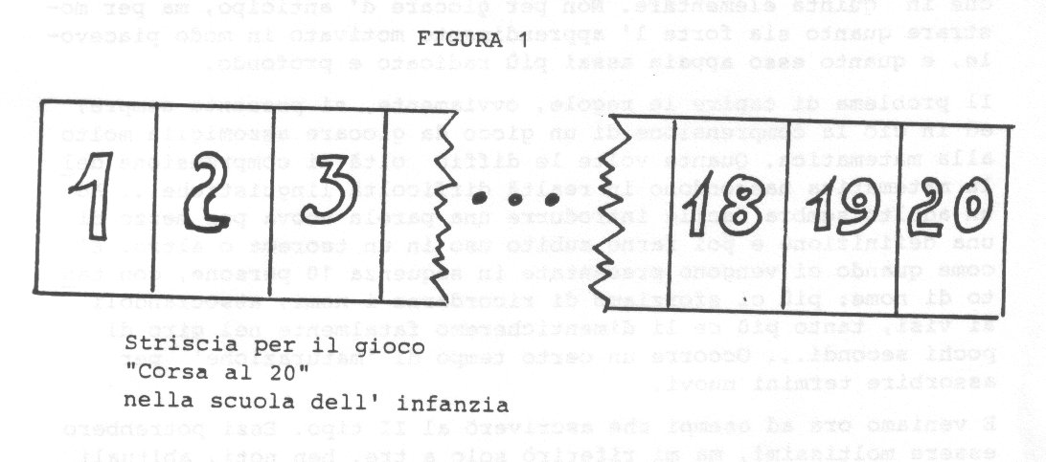
Nella scuola elementare, in (AAVV) si suggerisce questo tipo di gioco per avviare ad un uso elementare della calcolatrice tascabile; d'improvviso, nel passaggio tra il I° ed il II° ciclo, appaiono barlumi di consapevolezza del fatto che si può "costringere" l’avversario a dire un numero sbagliato; insomma: comincia a farsi luce l’idea di una strategia. In V elementare abbiamo la prova che la scelta della strategia a monte dipende dalla grandezza del numero posto come limite; corsa al 20 è facilmente dominato, corsa al 100 no.
Nella scuola media la strategia è dominata bene, per prova all’indietro (se voglio vincere, il mio avversario deve dire18 o 19; per costringerlo a dire 18 o 19 io devo poter dire 17, e così via). Una buona strategia.
Nella scuola superiore si fa luce la possibilità di formalizzare in modo matematicamente ineccepibile la strategia.
Ma c'è lo scoglio della non matematicità del problema proposto che andrebbe discussa da un punto di vista psicologico: quasi quasi gli studenti rifiutano, con un certo fastidio, di doversi occupare di matematizzare una situazione ludica.
Nulla di tutto ciò all’università, almeno nella mia esperienza, dove c'è un recupero di disponibilità...
Ma qui diventa stupido giocare a questo gioco che chiunque domina.

Esempio 2: Nim.
Per gli amanti delle citazioni storiche, una descrizione del Nim e della sua nascita si trova in (G1), P^{ag.} 130 e seguenti.
Senza qui spiegare le regole del gioco, molto noto nell’ambiente scolastico, si possono ripercorrere fasi analoghe a quelle precedenti.
Nella scuola materna, il gioco si può giocare ingenuamente ma con grande beneficio; è un piacere capire le regole, reinsegnarle a casa, spiegarle a voce ad un nuovo compagno, (e questa attività, a mio avviso, è già profondamente matematica).
Nella scuola elementare si comincia a vedere che ci sono situazioni vincenti, tali cioè che, qualsiasi mossa faccia l’avversario, io potrò farne un’altra che mi metterà nuovamente in situazione vincente.
Gli alunni imparano due - tre situazioni vincenti e si collegano sempre a quelle.
Nella scuola media non si ottiene molto di più, se non la capacità di imporre mosse all’avversario per costruire situazioni vincenti e la capacità di riconoscere più situazioni vincenti.
Nella scuola superiore abbiamo esperienze contrastanti; laddove il gioco è entrato di diritto nella pratica educativa quotidiana, è stato possibile riconoscere la strategia vincente generale, che si spiega bene ricorrendo alla numerazione in base due; ma dove ciò non è abituale, si è notata una sorta di fastidio in più allievi, con difficoltà di gestione.
Nel corso di "Matematiche Complementari" all’Università, propongo ogni anno il problema di trovare una strategia vincente del gioco, dopo averlo giocato più volte.
Di solito (tranne rarissimi casi) questa soluzione non viene trovata; qualcuno, più abile nella ricerca bibliografica, ricorre a testi sull’argomento (per esempio al già citato e ben noto (G1) ed allora scopre e capisce la regola.
Proprio per ovviare a questo, sono solito giocare al Nimo rovesciato: mentre nel Nim classico vince chi prende l'ultima pedina, nel Nim rovesciato perde chi è costretto a prendere l’ultima.
In questo modo costringo chi rintraccia la fonte a ragionare un bel po', di solito con buon risultato.

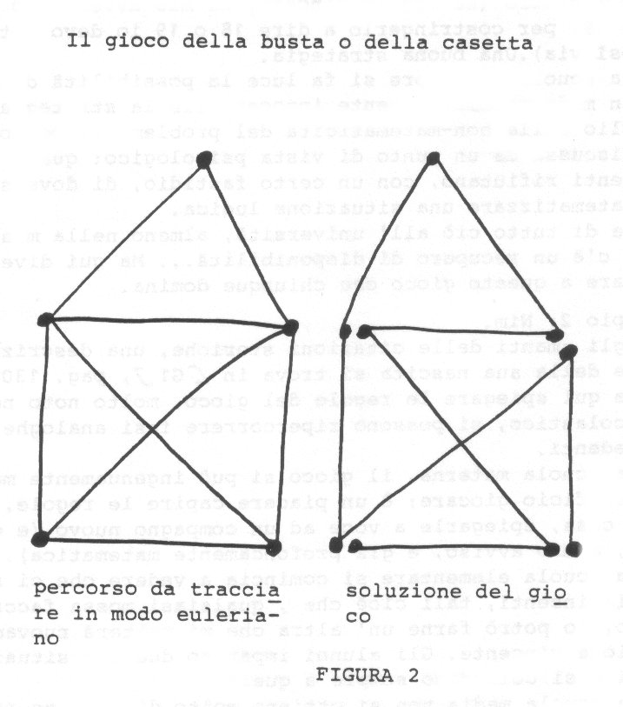
Esempio 3: Percorsi euleriani.

Disegnare la casetta (fig.2) con un sol tratto senza ripassare mai due volte sullo stesso segmento è un classico passatempo che non rientra tra i giochi a due persone e che includo qui per ampliare il ventaglio di esempi.
Nella scuola materna è un bel gioco, capire e giocare il quale è già una profonda conquista; lo si gioca su percorsi veri dapprima e poi su fogli, come è ampiamente documentato in (CDG). Se ben organizzato, si tratta di un gioco di grande interesse che si rivela molto piacevole per i bambini.
Nella scuola elementare abbiamo ampia esperienza di collegamento tra questo gioco e il teorema di Eulero sulla percorribilità delle reti piane.
Si tratta anzi del primo teorema che i bambini riconoscono e del quale ludicamente si appropriano, devo dire con grande sicurezza!
Nella scuola media si ha solo la possibilità di ampliare notevolmente la complessità delle reti prese in esame; abbiamo studiato percorsi di metropolitane, di fantomatici postini, ecc.
Nella scuola superiore, di solito, questo argomento non viene trattato; nelle classi con insegnanti interessati, però, lo studio è sviluppato nelle ore di Geometria.
Esso ci sembra necessario, specie in corsi come quelli degli Istituti Magistrali.
All’università la questione è trattata con molti particolari storici e tecnici, sempre con grande interesse degli allievi.
E’ sorprendente come l'interesse sia genuino: ragazzi di 22-23 anni, ad un passo dalla laurea, con anni di topologia alle spalle, che scoprono d’improvviso un legame tra futili giochetti da enigmistica e teoremi di una certa profondità, mostrano un vero e proprio entusiasmo.

Altri esempi:
“Il domino”, gioco all’apparenza banale, tant'è vero che in forma ingenua può essere giocato da bambini di 5 anni, che lo giocano per riconoscere le uguali tessere, è invece strategicamente piuttosto complesso; una curiosità: lungo il viale alberato che conduce all’università di Scutari, in Albania, abbiamo visto moltissimi gruppi di 4 anziani giocare a terra a questo gioco, con la stessa veemenza da noi riservata nei bar alla briscola...
I giochi di carte, dalla briscola al micidiale poker, molto studiati dai matematici; per esempio, il poker è ampiamente studiato in (NM).
Si noterà che ho evitato appositamente di parlare di giochi concernenti la probabilità, per i quali è necessario un apposito capitolo a sé stante.

Riferimenti bibliografici.
(AAW) Autori Vari, Progetto MaSE, Angeli, Milano; i volumi da I a VII sono stati pubblicati tra il 1986 e il 1987;ivolumi VIII-IX e XA appariranno nel NOVEMBRE 1992; il volume finale XB nel corso del 1993.
(A) F. Arzarello, Bambini, giochi e costruzione del sapere matematico;
luci ed ombre, in (D3), pagg. 7-14.
(AB) A.Barlotti, Una breve panoramica sui legami tra Giochi e Matematica, in (D1), pagg. 17-20.
(B) G.C.Barozzi, II gioco tra due persone come metafora di alcuni procedimenti matematici, in (D3), pagg. 15-18.
(CDG) M.L.Caldelli-B.D'Amore-L.Giovannoni, II bambino matematizza il mondo, La Nuova Italia, Firenze 1985.
(D1) B.D'Amore (a cura di), Gioco e matematica, Atti dell’omonimo Convegno Nazionale, Bologna 8-10/09/86, Cappelli, Bologna 1986.
(D2) B.D'Amore, Elementi di Teoria dei Giochi, Zanichelli,
Collana MM 1 2, Bologna 1976.
(D3) B.D'Amore (a cura di), Matematica; giocoed apprendimento,
Atti dell’omonimo Convegno Nazionale, Castel S. Pietro T. 16-18/11/90,.
(G1) M.Gardner, Enigmi e giochi matematici, voi. I, Sansoni, Firenze 1972
(ma già pubblicato in italiano nel 1967; raccolta di testi apparsi su "Scientific
American" tra il 1956 e il 1958 in un volume in USA 1959).
(G2) M.Gardner, Enigmi e giochi matematici, voi. II, Sansoni, Firenze 1973
(ma già apparso in italiano nel 1968; raccolta di testi apparsi su "Scientific
American" tra il 1958 e il1960 ed in volume in USA nel 61).
(M) R. Magari, Le basi elementari della matematica, Sansoni, Firenze 1989.
(MP) N.Malara-C.Pellegrino, II gioco come mezzo per promuovere una
corretta immagine della matematica, in (D3), pagg. 53-62.
(NM) J.Von Neumann-0.Morgenstern, Theory of Games and Economic Behavior,
John Wiley & Sons Inc., New York 1944 (ma io cito dalla III ed., 1967).
- G.Peano, Giochi di aritmetica e problemi interessanti, Paravia, Torino 1924
(ma io cito dalla edizione Sansoni, Firenze 1983).

Gli scacchi come strumento per la didattica della matematica.
Luca Barzanti - Stefania Fabbri.

l. La matematica e gli scacchi.
La matematica costituisce un mondo affascinante che può essere avvicinato e apprezzato sin dalla giovane età, soprattutto se presentato in maniera divertente, mettendone in risalto non tanto i formalismi, quanto le idee e gli aspetti creativi, stimolando la curiosità e l'apprendimento.
II gioco rappresenta in tal senso uno strumento ideale e numerose idee matematiche si prestano ad essere proposte sotto forma di gioco: la matematica cosiddetta dilettevole, che ha appassionato nei secoli studiosi e profani, è un modo efficace per avvicinarsi con spirito creativo a concetti e problemi tutt'altro che banali.
II gioco non è solo un importante supporto didattico, ma anche un aspetto del comportamento umano, che va mantenuto e verso cui educare.
Ciò non significa che occorra inventare la materia 'educazione al gioco', ma piuttosto che l'insegnamento delle varie discipline possa avvenire anche attraverso elementi di gioco.
Per quanto riguarda in particolare la matematica, il gioco degli scacchi assume un ruolo di primaria importanza.
La sua complessità strutturale e ricchezza intrinseca, infatti, ne fanno un mondo per certi aspetti assimilabile a quello matematico, tant'è che i legami tra matematica e scacchi sono da sempre materia di studio a partire da temi elementari e fantasiosi (come quello dei chicchi di grano da disporre in una successione determinata sulla scacchiera per ricompensare il leggendario inventore del gioco ), fino ad arrivare ad argomenti più concreti e complessi, come i problemi classici, tra cui il celeberrimo 'salto di cavallo¹, affrontati da grandi matematici; come Eulero.
Lo svolgersi stesso della partita ha qualcosa in comune con l'esperienza dello studio matematico: nella fase di apertura il Giocatore utilizza tra le sue conoscenze di teoria quelle necessarie ad impostare correttamente un particolare tipo di gioco, così come il matematico, affronta un problema dapprima attingendo dal proprio sapere quei particolari strumenti che occorrono nello specifico.
Inquadrare nell'evolversi un'apertura è come sviscerare una questione matematica nei suoi vari aspetti.

Nel centro partita la creatività e l'intuizione si fondono con le capacità logiche necessarie per 'vedere' una situazione in evoluzione, così come la scoperta ma
tematica necessita di un coinvolgimento totale delle diverse capacità umane allo scopo di trovare un collegamento prima sconosciuto.
II finale è la parte metodica della partita; è l'unica fase completamente teorizzabile: nelle varie circostanze si riesce a determinare il vincitore e in linea di principio il procedimento che porta alla vittoria.
E' così anche in matematica ove, giunti in certe situazioni o scritte certe equazioni, si sa che il problema può essere portato a completa risoluzione utilizzando tecniche note.
Ancor più della partita il problema di scacchi è simile ad un problema matematico: alle considerazioni precedenti, nella sostanza ancor valide, si aggiunge la coincidenza degli scopi (ora in entrambi i casi c'è un problema da risolvere) e della fase di impostazione: la formulazione del problema è univoca e rigorosa e occorre intraprendere il ragionamento studiando le proprietà.
In definitiva si direbbe che le qualità del bravo scacchista sono le stesse caratterizzanti il buon matematico.
G.H.Hardy ha scritto nella sua 'Apologia di un matematico': «Ogni paese civile conta innumerevoli giocatori di scacchi (in Russia quasi tutte le persone colte giocano a scacchi), che sanno apprezzare la 'bellezza' del gioco o di un problema.
Ebbene, un problema di scacchi non è altro che un esercizio di matematica pura
(una partita non lo è del tutto, perché in essa entrano in gioco fattori psicologici).
Ora, se un problema di scacchi viene definito 'bello' è la sua bellezza matematica che viene esaltata,...».
Hardy introduce un altro importante elemento comune alle due discipline, che è quello dell'estetica.
La passione e il godimento che il matematico prova nella scoperta sono in qualche modo simili ai sentimenti dello scacchista che vince una partita o risolve un problema, e questo non solo per il compiacimento della forza delle idee sviluppate, ma anche per il senso di armonia e di ordinata bellezza che quanto compiuto produce.
Un ulteriore elemento comune alle due discipline è il rapporto tra concretezza e astrazione.
La capacità di astrazione necessaria per poter 'far bene' matematica deve essere opportunamente compenetrata nella fase didattica con l'esigenza di concretezza del neofita, così come nel gioco degli scacchi vanno giustamente calibrate l'esigenza di concretezza (spostare i pezzi sulla scacchiera) con la necessità di astrazione della regola del 'pezzo toccato, pezzo mosso', che impone di saper 'vedere' la posizione in evoluzione senza toccare i pezzi.
Educare all'astrazione negli scacchi, dunque, è utile per l'acquisizione dell'astrazione matematica, che rappresenta una tappa decisiva nell'apprendimento in questo campo.
E’ ora il momento di occuparsi di come gli scacchi siano utili nell'insegnamento di diversi argomenti di matematica.
I seguenti esempi sono il frutto non solo di una elaborazione compiuta a tavolino, ma anche della concreta esperienza vissuta coi bambini.
E' opportuno precisare che gli scacchi si correlano anche alla matematica di alto livello (calcolo combinatorio, ecc.), ma preferiamo in questa sede limitarci ad esempi riguardanti argomenti di più facile ed ampia applica
2.Il problema di scacchi.
E' possibile sviluppare alcuni elementi di logica e di informatica utilizzando il problema di scacchi; si potrebbero cioè impostare lezioni in cui parallelamente al concerto di problema di scacchi vengono introdotti elementi di logica e di logica –
informatica.
Lo scopo è quelle di dare concretezza e senso immediato a quanto si propone catturando nelle stesso tempo l'attenzione del bambino con continue variazioni di ritmi e di temi. In letteratura non abbiamo trovato definizioni di problema di scacchi che risultino precise e complete.
Di solito si usa definirlo come segue :« si intende per problema di scacchi una posizione di pezzi creata dalla mente del compositore nella quale il Bianco, con un numero di mosse prestabilite, deve dare scacco matto al Nero o viceversa.» [1].
E' facile convincersi che tale definizione da luogo ad ambiguità.
Si prenda ad esempio la posizione illustrata nel diagramma seguente:
B: Rhl,Dc2,Ab4,Ac4,Ca3,Cb3;
N: Ra2,Tb2,

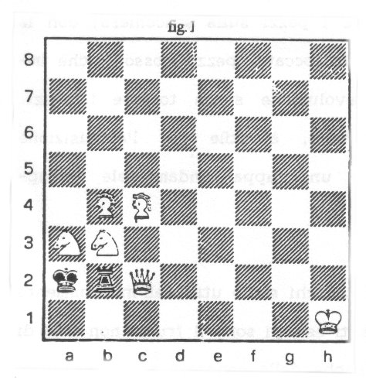
La sequenza di mosse: 1. Del, se l....,Tc2, allora 2.Dbl#; se l....,Tb1+ allora 2.Dxb1# non costituisce una soluzione del problema, poiché non contempla tutte le possibili varianti.
Infatti se l....,Th2+ non è possibile trovare una contro mossa del Bianco che dia scacco matto. Nella definizione precedente tale aspetto, benché insito in ‘deve dare’, non è sufficientemente esplicitato tant'è che molti bambini a cui il problema viene così spiegato sono convinti di averlo risolto ogni qualvolta si trovano di fronte ad una situazione come quella ora descritta.
Cerchiamo di chiarire cosa significa risolvere un problema, prendendo per semplicità in esame problemi in due mosse in cui è il Bianco a dare scacco matto: occorre trovare una messa del Bianco (che esiste, è unica ed è detta 'mossa chiave') tale che per qualsiasi risposta del Nero esista una mossa del Bianco che dia scacco matto.
Tale formulazione, estendibile con piccole precisazioni in modo 'ricorsivo' ad un qualsiasi numero di mosse, mette in luce la presenza dei due quantificatori
universale ("Y") ed esistenziale ("X").
Col loro utilizzo e con l'ausilio dei simboli indicanti 'tale che ('/') e l'unicità ('!'), è possibile dare una formulazione matematica:
X mossa chiave del Bianco, Y contro mossa del Nero, X mossa del Bianco #,
o, indicando con B1 la prima mossa del Bianco, con N1 la prima del Nero, e così via,
X! B1 / Y N1 X B2 / #
E' stato compiuto un processo di astrazione: i quantificatori non sono comparsi dal nulla, ma hanno nello specifico un significato ed una funzione comprensibile per il bambino, che è così venuto a contatto, in modo indolore, col formalismo matematico.
Ciò ha un significato importante, poiché ci sono studi che mostrano come l'avversione per la matematica sia originata anche dal rifiuto dei suoi formalismi [2].
E’ ora possibile illustrare in altri contesti i simboli introdotti, abituando così al valore semantico del simbolo.
Si può mostrare con esempi molto semplici come scambiando le posizioni dei due quantificatori cambi completamente il significato delle proposizioni: 'X una mamma Y figlio maschio’ è vera, mentre 'Y mamma X un figlio maschio' è chiaramente falsa.
Lo stesso si può dire per 'Y micio, X una coda’ e 'X un micio Y coda’.
Ci sembra anche in questo caso utile rilevare l'importanza della capacità di collegare automaticamente simbolo e significato, ricordando come non sia infrequente la confusione nello studente quando le situazioni si complicano, come spesso accade in molti argomenti di analisi matematica.
L'albero delle varianti, struttura grafica che riassume le varianti del problema,
è in sostanza un diagramma di flusso, strumento utilizzato nell'approccio alla
logica del calcolatore e più in generale al pensiero algoritmico.
Può dunque essere interessante, costruito l'albero delle varianti del problema analizzato (vedi fig.2), studiarne le caratteristiche e utilizzarne la struttura per il trattamento di altri problemi. E' qui opportuno insistere sul fatto che è il solutore a dover accertarsi di aver esaurito positivamente tutte le possibilità, così come il programmatore, deve assicurarsi che il suo programma contempli tutti i casi che si possono; verificare. E’ interessante mostrare come la struttura sia estendibile a problemi in più mosse (fig.3) e presentare qualche esempio di situazioni schematizzabili; con diagrammi di flusso, introducendo eventualmente la struttura 'ciclo', mancante nei diagrammi di problemi di scacchi ( fig. 4 e 5 ).
Mossa chiave: l.Dh7
Se l....,Tb1+,allora 2.Dxbl#
Se l...., Txb3, allora 2.Db1#
Se l.…, Th2+, allora 2.Dxh2#,
Se 1.….., T xx 2 allora 2.Dbl # .

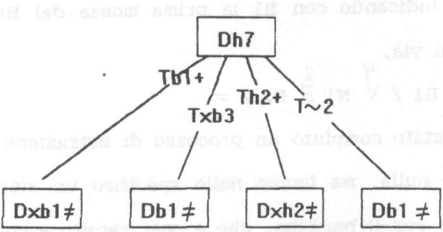
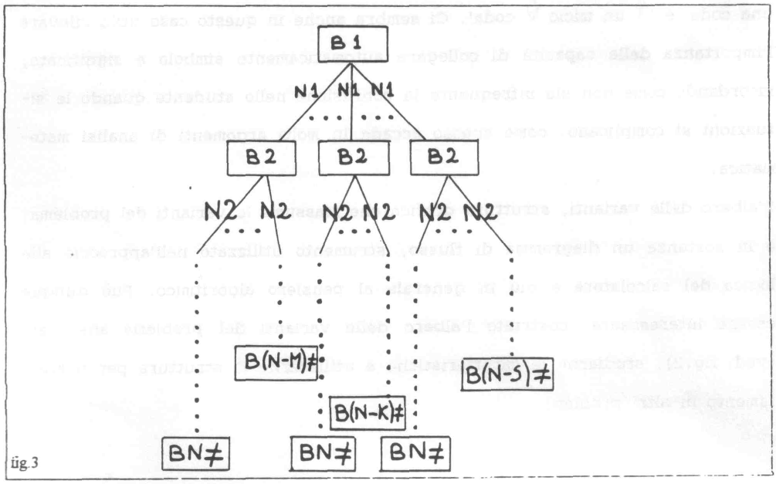
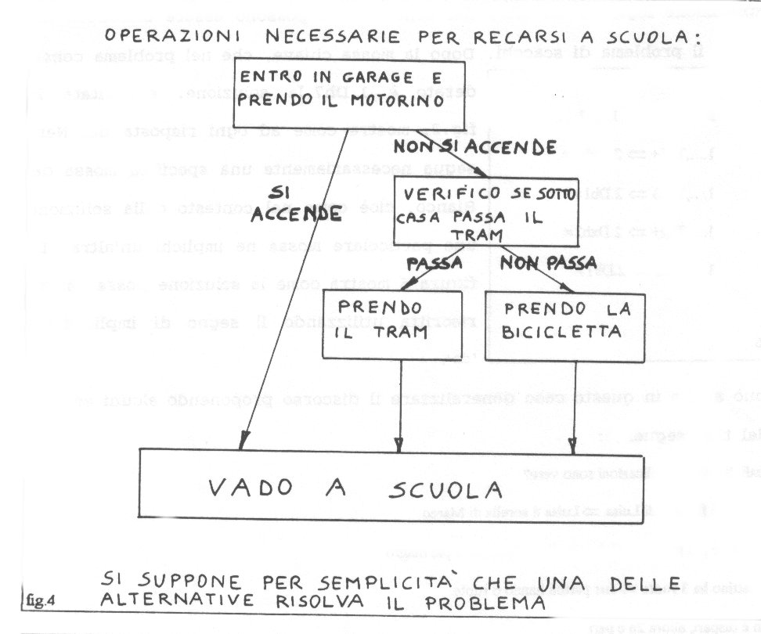

L'implicazione logica è un altro dei concetti che possono essere introdotti attraverso il problema di scacchi.
Dopo la mossa chiave, che nel problema considerato è l.Dh7,la soluzione, esplicitata in fig.2, mostra come ad ogni risposta del Nero segua necessariamente una specifica mossa del Bianco, cioè come nel contesto della soluzione una particolare mossa ne implichi un'altra. La figura 6 mostra come la soluzione possa essere riscritta utilizzando il segno di implicazione “=>”.

Si può anche in questo caso generalizzare il discorso proponendo alcuni esercizi del tipo seguente:
Quali di queste implicazioni sono vere?
- Marco è fratello di Luisa => Luisa è sorella di Marco
- Se Aldo è più grasso di Gabriele allora Gabriele è più magro di Aldo
- Un pattino ha 3 ruote => due pattini hanno 6 ruote.
- Se n è dispari, allora 2n è pari.
- Se questa settimana piove tutti i giorni, allora la prossima settimana si
avrà almeno una giornata di sole.
f) Solo gli uomini mangiano => i gatti non mangiano.
g) Tutti gli uomini mangiano => i gatti non mangiano.
- Se Piero è padre di Marco e Marco è padre di Luca,
allora Piero è padre di Luca.
i) Tutti i bambini vanno a scuola => i cani non vanno a scuola
l) Tutti i camini fumano; mio nonno fuma => mio nonno è un camino

Indicare l'implicazione corretta:

Tutti gli uomini portano il cappotto
- Gli uomini grandi portano il cappotto grande
- Gli uomini grandi portano il cappottone
- Gli uomini grandi portano li cappotto

Il compito di rappresentare parallelamente il problema di scacchi ed i suoi spetti matematici può presentarsi piuttosto articolato.
E’ perciò possibile una metodologia didattica diversa, che preveda prima le spiegazioni riguardanti il problema di scacchi e solo successivamente l'introduzione degli aspetti matematici ad esso correlati.
In questo caso, la seconda fase rappresenterà per il bambino una presa di
coscienza dei meccanismi e degli strumenti logici appresi e di come tutto ciò sia utilizzabile nei più svariati ambiti tra cui quello logico e matematico, con la veloce e piacevole acquisizione di un linguaggio più rigoroso e comprensibile.
La polivalenza del problema di scacchi come strumento educativo in ambito matematico è sorprendente.
Vogliamo qui presentare, a conclusione di questo tema, due problemi eterodossi: l'uso della logica non deve limitarsi solo ad un tipo di schema e queste varianti del problema classico sviluppano l'elasticità mentale, qualità necessaria al buon matematico e presupposto fondamentale per quei 'mutamenti di paradigma' che
secondo Kuhn accompagnano sempre le grandi rivoluzioni scientifiche[3].
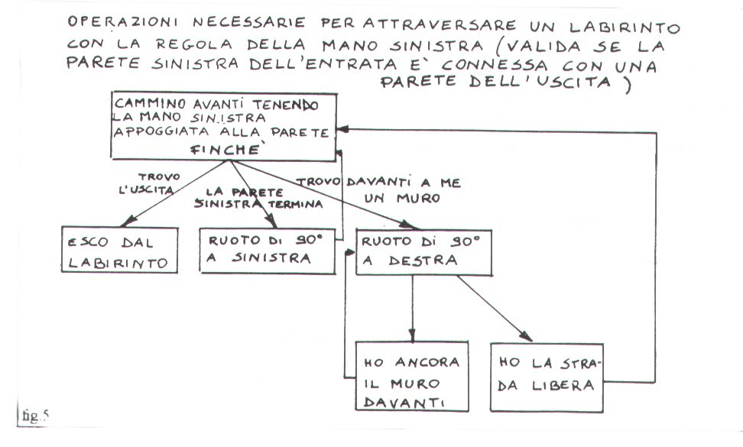
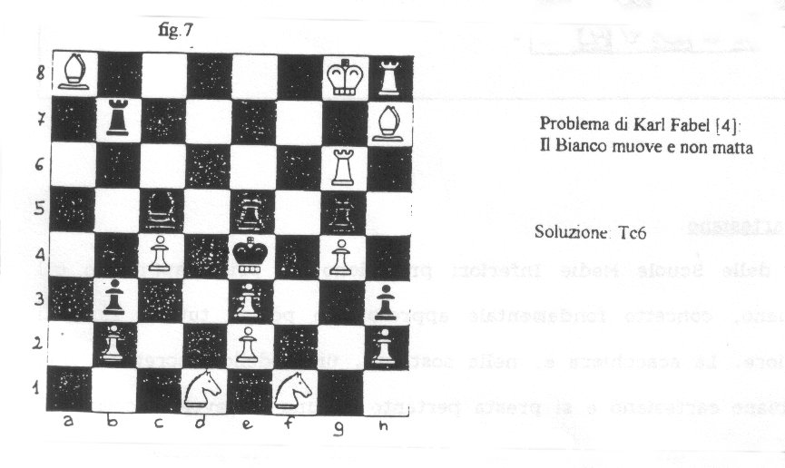

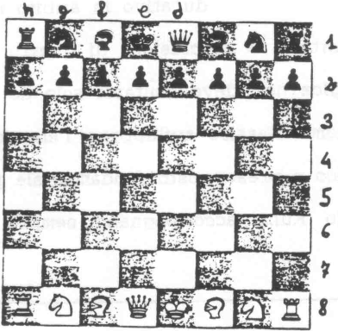
Fig.8 Problema di Lord Dunsany [5]: questa posizione è possibile, cioè può presentarsi nel corso di una partita Il Bianco muove e matta in 4 mosse. La soluzione richiede più pensiero logico che abilità scacchistica, sebbene sia necessario conoscere le regole del gioco. La chiave del problema è nel fatto che la Regina nera non è su casella nera come dovrebbe essere all'inizio del gioco.
Ciò significa che Re e Donna neri sono stati mossi e questo può essere avvenuto solo se si sono mossi dei pedoni neri; ma questi ultimi non possono andare all'indietro. per cui bisogna dedurne che i pedoni neri hanno raggiunto le loro attuali posizioni provenendo dall'altro lato della scacchiera.

Soluzione: l.Cd7 Se 1… Cf3,

allora 2. Cc5 Ce5; 3.Dxe5, ~ , 4.Cd3 #

Altrimenti 2.Ce5 e poi matto in f3 o in d3

3) II piano cartesiano.
I programmi delle Scuole Medie Inferiori prevedono un primo approccio col piano cartesiano, concetto fondamentale approfondito poi in tutti i rami di studio superiore. La scacchiera è, nella sostanza, un modello discreto di una porzione di piano cartesiano e si presta pertanto ad una piacevole e comprensibile introduzione a diversi argomenti, anche complessi.
Più precisamente, la scacchiera è una successione di livelli discreti rappresentati nel continuo per una esigenza materiale ed estetica; si consideri infatti che non sono possibili posizionamenti tra una casella e l’altra: è come se il pezzo si muovesse dal centro di una casella al centro di un’altra. Si può assimilare la scacchiera al modello costituito dai punti di intersezione di un reticolo discreto in cui tali punti sono materialmente rappresentati da quadrati confinanti tra loro (fig.9).
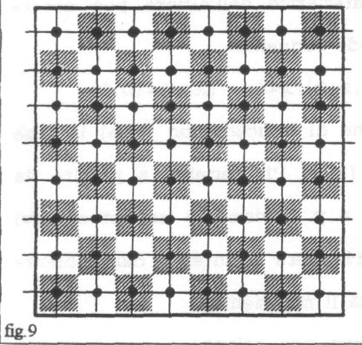
Ogni casetta è contrassegnata da un'ascissa (lettera) e da un'ordinata (numero), ma si può facilmente passare ad una rappresentazione in cui entrambe le coordinate sono numeri, introducendo il concetto di coppia ordinata.
Anche il video di un calcolatore è costituito da tante piccole 'caselle' (pixel) ciascuna delle quali è posta in corrispondenza biunivoca con un elemento di una matrice
(determinato univocamente da una coppia ordinata di numeri) .
’Ponendo’ gli elementi della matrice uguali a 1 o a 0, il computer può 'dire’ al
video quali pixel devono essere accesi e quali spenti, determinando così
un'immagine voluta. Riferimenti come questo, utili di per sé nell'introdurre qualche nozione di logica digitale, costituiscono anche un valido espediente didattico per collegare l'argomento trattato a realtà che i bambini in qualche modo conoscono, e ciò allo scopo di stimolarne l'attenzione e l'apprendimento.
L'istituzione di 'ancore mentali', col continuo riferimento a situazioni conosciute, costituisce un valido strumento pedagogico di polivalente utilità.
In quest'ottica è possibile introdurre caratteristiche matematiche del movimento di ciascun pezzo, presentandole come il 'carattere' e la 'personalità' che lo distinguono all'interno del mondo scacchiera.
Descrivendo casella per casella il percorso di ogni pezzo si può estrapolare la legge matematica che ne contraddistingue il movimento.

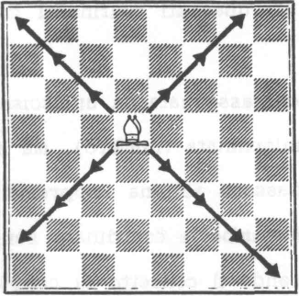
Fig. 10 L'Alfiere, ad esempio, si muove in diagonale di un qualsivoglia numero di passi
Ricordando che la scacchiera è l'universo in cui ci poniamo, e quindi il movimento deve necessariamente essere limitato al suo interno, il carattere matematico dell'Alfiere può essere indicato nel modo seguente:
(a,b)—>(a+x,b+y) / x = ± y, (x,y) ≠(0,0), dove si conviene di indicare con (a,b)la casa di partenza e (x,y)l'incremento a partire da questa, con x e y ovviamente numeri relativi compresi nel range che consente al pezzo di rimanere all'interno
dell'ambiente di gioco. E’ il legame tra x e y che caratterizza il movimento.

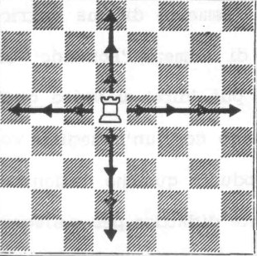
Fig. 11 La Torre si muove per colonne e per traverse di un qualsivoglia numero di caselle
(a,b)—>(a+x,b) x ≠ 0, vel
(a,b)—>(a,b+y), y ≠ 0.
Ora tocca ai bambini matematizzare il movimento dei pezzi.

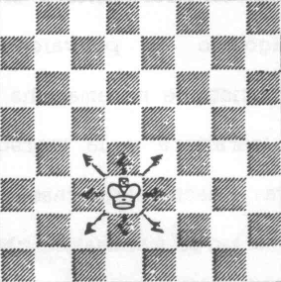
Fig. 12
II Re si muove di una sola casella in tutte le direzione:
(a,b)—>(a+x ,b+y)/- ≥ x ≥ y1,
-1 ≥ y ≥1,(x,y) ≠ (0,0) ≥≠

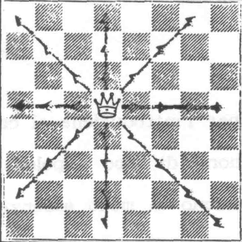
Fig. 13
II movimento della Donna è l'unione dei movimenti
della Torre e dell'Alfiere:
(a,b)—>(a+x,b) / x ≠ 0, vel
(a,b)—>(a,b+y)/ y ≠ 0, vel
(a,b)—>(a+x,b+y) / x = ± y,(x,y) ≠ (0,0)

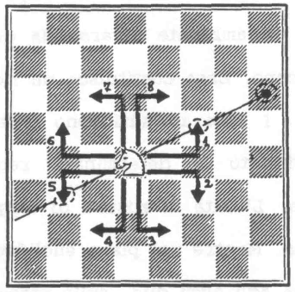
Fig.14 Il Cavallo, infine, ha il caratteristico movimento ad ‘L':
(a,b)—>(a+x,b+y)/x=±2y vel y=±2x,
x,y ≠ 0, con –2<x<i2, -l<y<l,
vel - l<x<l,-2<y<2.
Si può anche considerare un nuovo pezzo, il cavallo 'birichino¹, la cui caratterizzazione matematica coincide con quella del cavallo, senza le ulteriori limitazioni su x e y :
(a,b)—>(a+x,b+y) / x =± 2y
vel y= ±2x, x,y ≠ 0.
La mossa del pezzo consiste dunque nella successione di un qualsiasi numero di mosse del cavallo ortodosso compiute tutte lungo la medesima direzione (per esempio lungo la direzione 1 di fig.l4).
Il movimento avviene cioè lungo le rette di coefficiente angolare ±2 vel ±1/2.
Se, compiendo il movimento di un pezzo, si pone un segno su ogni casella percorsa, risulta facilmente comprensibile come derivino figure rettilinee: le leggi matematiche presentate caratterizzano rette o segmenti.
Il bambino può a questo punto comprendere intuitivamente come anche altri enti geometrici possano essere descritti con una legge matematica e come il calcolatore, li possa disegnare per punti conoscendone l’equazione algebrica.

- Lo spazio ambiente.
La scacchiera si presta anche a interessanti spunti per l'introduzione al concetto di spazio ambiente e a semplici considerazioni di tipo topologico.
L'esistenza e le proprietà degli enti matematici dipendono in modo essenziale
dall'ambiente in cui vengono considerati.
Così come certi enti vivono solo in determinati spazi, allo stesso modo altri mutano le loro caratteristiche in funzione dello spazio in cui si trovano.
E' importante che il bambino comprenda tali concetti e la scacchiera, come esempio di un ambiente diverso da quello euclideo, può particolarmente prestarsi a tale scopo.
Essa costituisce un mondo bidimensionale caratterizzato da regole proprie.
I suoi abitanti sono i pezzi, ciascuno dei quali obbedisce nel suo movimento a determinate regole, compatibili con quelle che definiscono l'ambiente.
L'unità di misura di tempo è la mossa, mentre quella di lunghezza è la casella.
Mentre nel piano euclideo un lato di un triangolo è sempre minore della somma egli altri due, sulla scacchiera non è così

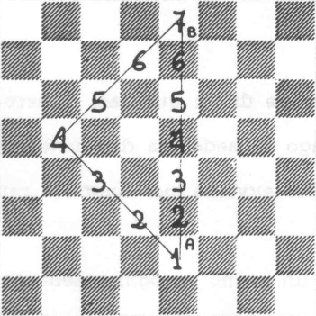
Si consideri ad esempio la lunghezza dei due diversi percorsi che il Re deve compiere per andare da A a B
.Fig. 15
In entrambi i casi il percorso è di sette caselle.
Nel piano euclideo si possono individuare infinte direzioni, mentre la scacchiera è un ambiente con un numero di direzioni a priori ben determinato dai fatto che è un universo discreto e limitato.

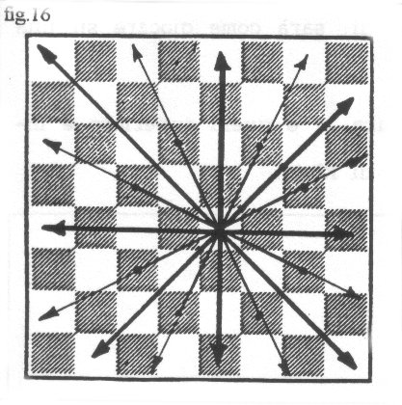
Le regole di movimento dei vari pezzi, che ne costruiscono la struttura, ne escludono la quasi totalità, cosicché ne rimangono otto e sedici versi effettivamente possibili (fig. 16).
Quattro di queste risultano privilegiate.
Le altre possono essere assimilate a queste se si ammette l’uso del cavallo “biricchino.

Consentendo ai pexxi di prolungare il proprio movimento al di là dei limiti della scacchiera e fissando opportunamente le leggi che regolano tali possibilità si opera
un mutamento topologico che trasforma l'ambiente di gioco.
Ci sembra un obiettivo interessante portare i ragazzi a contatto con qualche questione di topologia; una loro comprensione intuitiva costituirà già un buon risultato.
Le regole sintetizzate in figura 17 corrispondono all'identificazione di due bordi laterali della scacchiera e trasformano di fatto l'ambiente di gioco in un cilindro.
L'introduzione di regole analoghe anche per i lati orizzontali rende la scacchiera simile a un toro.
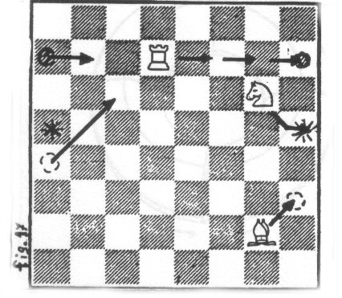
Analogamente, qualora si consenta ai pezzi, giunti a un bordo laterale di 'riapparire¹ sul lato opposto in posizione simmetrica alla precedente rispetto alla linea di metà campo, (fig.18) la scacchiera sarà simile a un nastro di Mobius e, se la stessa identificazione verrà effettuata sugli altri due bordi, sarà come giocare su una sfera.
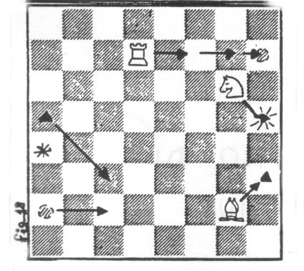
Identificando infine i bordi laterali come in figura 17 e quelli superiore e inferiore come in figura 18, si ottiene una bottiglia di Klein.
5) Conclusioni.
Quanto detto e gli esempi illustrati sono a nostro avviso sufficienti a convincere che gli scacchi non sono solo un gioco affascinante, logico e genericamente formativo, ma che possono essere utilizzati con profitto in didattica della matematica ai vari gradi di scolarità.
Vale dunque la pena di procedere nell'approfondimento di tematiche riguardanti gli scacchi, a nostro parere principalmente in due direzioni:

Ricerca, sviluppo e precisazione di metodologie che utilizzino gli scacchi per un insegnamento più stimolante di particolari argomenti di matematica.
Elaborazione di metodologie che utilizzino i vari aspetti e manifestazioni dell’attività scacchistica (studio della teoria, soluzione di problemi, tornei, partite da analizzare, partite da giocare con poco o molto tempo, simultanee da condurre o da giocare,... ) allo scopo di sviluppare più in generale le attitudini e le capacità logiche e matematiche.

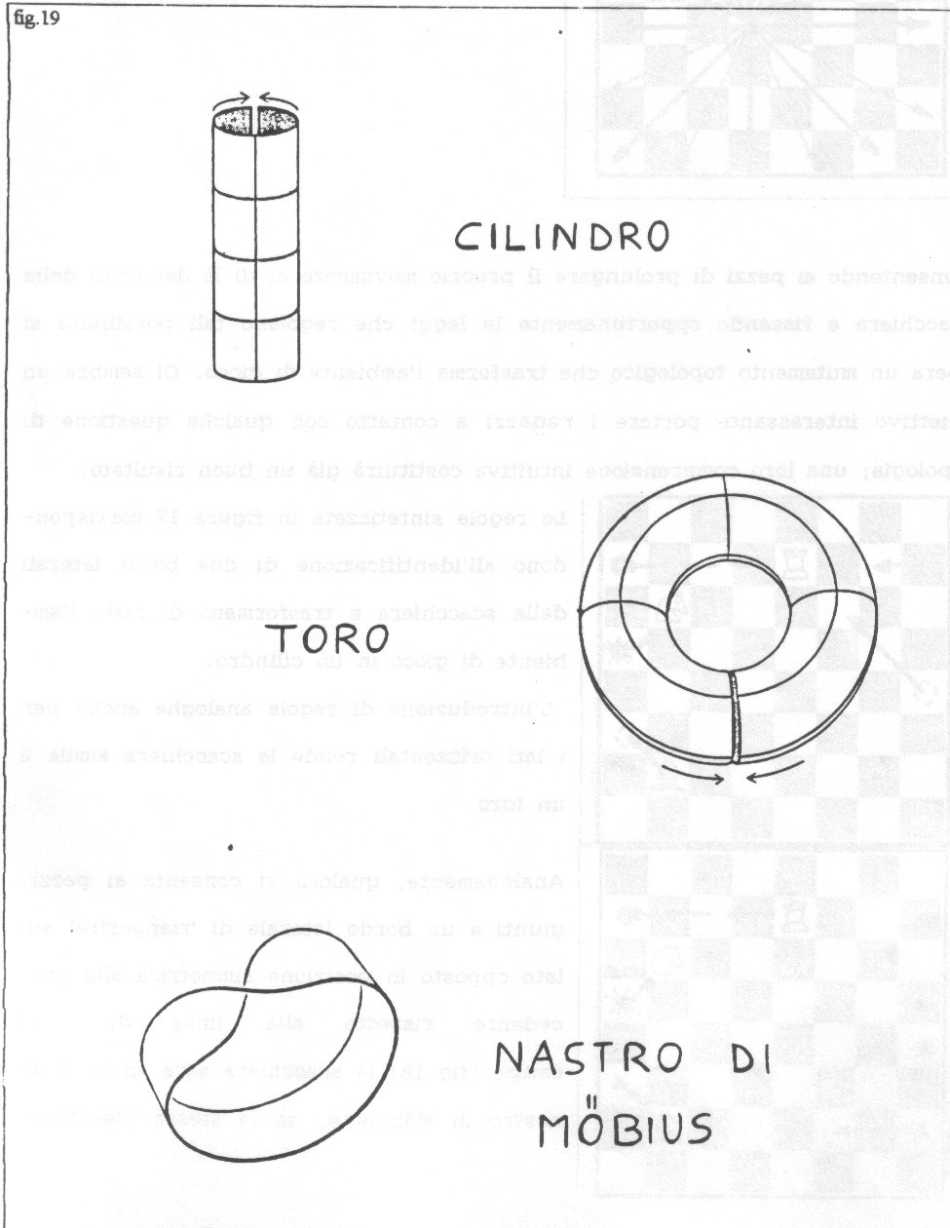
Bibliografia

[1] A.Chicco e G.Porreca, II libro completo degli scacchi. Mursia, 1973, pag.417.
[2] J. Canestri e S. Oliva. La matematica sul lettino. Sapere, Gennaio
(pagg.45-56) e Febbraio (pagg. 29-37) 1992.
[3] T.S.Kuhn, La struttura delle rivoluzioni scientifiche, Einaudi, 1978.
[4] M.Gardner, Enigmi e giochi matematici, voi.3, Sansoni, pag.218.
[5] M.Gardner, Enigmi e giochi matematici, voi.2, Sansoni, pagg.123,128.
SCACCHI E PROBABILITÀ
di Roberto Magari

Da tempo sappiamo che, specialmente in Italia, ciò che viene inteso di solito per cultura è monco: viene ignorata la cultura scientifica.
Abbiamo fortunatamente alcuni bravi divulgatori ma spesso essi sono in difficoltà con la matematica, anche perché, come ebbe a dire di recente uno di loro, pur bravo
e famoso: "La matematica non si presta ad essere spiegata per immagini".
Bisogna anche dire che spesso i matematici non sanno o non vogliono condividere con altri il loro "giardino incantato" (prendo a prestito questa locuzione fra il romantico e il lezioso dal titolo di un libro divulgativo che mi fu utile da giovane).
Un'altra lacuna nella formazione media riguarda gli scacchi e anche i giochi
in generale; le due lacune, credo, sono connesse e può essere una buona idea quella di combattere una battaglia comune.
Già la vita quotidiana offre a iosa spunti matematici; mi limiterò a due soli esempi. Quando ero ancora più giovane di ora non potevo permettermi un orologio da polso
e cercavo di supplire guardando gli orologi da muro che allora erano presenti in quasi tutti i negozi.
Ben presto mi posi il problema di come stimare l’ora in presenza di indicazioni discordi e quest'occasione mi introdusse a concetti probabilistici forse meglio di
un trattato.
Supponiamo che uno debba attraversare la strada diagonalmente sotto la, pioggia ma che una parte della larghezza della strada sia coperta: che tipo di percorso dovrà seguire se valuta in un certo modo i danni della pioggia e in un
certo altro il danno di un percorso più lungo?
Lo studio di questo banale problema introduce benissimo ai problemi di minimo in genere (addirittura, se vogliamo, al calcolo delle variazioni) e permette anche di capire meglio la rifrazione.
Se già la vita quotidiana offre spunti per riflessioni matematiche è da presumere che ancor più ne offrano i giochi e specialmente gli scacchi.
Di questo fenomeno ci sono interessanti esempi classici, come il problema delle otto donne, il problema delle cinque donne, i problemi relativi al movimento
del cavallo, la teoria delle case reciproche nei finali di pedoni e in altri finali.
In questa chiacchierata darò tre nuovi esempi di problemi di ispirazione scacchistica che possono servire ottimamente da spunto per riflessioni matematiche di carattere
probabilistico.

1. La "fortuna" e gli scacchi.
Appartenendo all'onorata categoria scacchistica dei "polli" ho una naturale indulgenza verso chi, avendo perso, parla di circostanze avverse o addirittura di "sfortuna".
Questo non toglie che a prima vista i luoghi comuni circa l'assenza di questo fattore dagli scacchi siano attendibili.
Per affrontare l'argomento occorre anzitutto sovrapporre al concetto vago di "fortuna" del senso comune un concetto rigorosamente definito: sarà, se lo si farà con giovani scacchisti o aspiranti matematici, una delle tante occasioni per mostrare che uno dei vantaggi della matematica è proprio quello di fornire strumenti per sovrapporre ai concetti del senso comune concetti rigorosamente definiti.
Supponiamo, si dirà, di essere in una situazione cui possono seguirne altre:
s-1, s2....,s_{n} di probabilità rispettive p1, p2….Pn; si chiama allora "speranza" o "utilità" la somma: u = p1 v1 + p2 v2+...+pn vn.
Supponiamo ora che di fatto si verifichi una situazione, fra quelle elencate come possibili, di valore v; sembra abbastanza aderente al senso comune chiamare fortuna (del protagonista, in quelle circostanze) la differenza v-u e, se vogliamo, sfortuna il suo opposto u-v.
Se si vuole che questa teoria risulti applicabile conviene che le probabilità e i valori siano presi in un opportuno campo non archimedeo, che il valore 0 sia riservato agli eventi impossibili e il valore 1 agli eventi certi.
Tornando agli scacchi occorre anzitutto chiarire che il gioco è determinato, nel senso che si verifica una (e una sola) delle seguenti possibilità:
a) Esiste una strategia vincente per il Bianco;
b) Esiste una strategia vincente per il Nero;
c) Esistono due strategie di patta, una per il Bianco e una per il Nero.
Sono cose ovvie ma uno dei compiti di chi vuole insegnare matematica è proprio quello di far notare le cose ovvie e di far constatare quanto l'esplicitarle sia utile
per le analisi successive.
Il docente potrà qui attardarsi sul concetto di strategia.
L'argomento si presta anche ad una importante osservazione; quasi tutti gli scacchisti sono convinti che il caso b), strategia vincente per il Nero, non si verifichi ma naturalmente nessuno, che si sappia, è in grado di dare una dimostrazione di questa congettura. Si tratta di uno dei rari casi in cui una congettura matematica priva di dimostrazione viene ritenuta pressoché sicura.
Se gli ascoltatori hanno interessi epistemologici sarà qui il caso di invitarli a discutere sul tipo di "certezza" dato dalle dimostrazioni, sul caso delle dimostrazioni molto lunghe o eseguite soltanto da calcolatori, sulla capacità del senso comune e del senso comune matematico di avanzare congetture probabili ecc.
II fatto che il gioco sia determinato non significa certo che noi siamo in grado in un tempo ragionevole di decidere quale delle tre (o delle due se ci sentiamo di escludere l'esistenza di una strategia vincente per il Nero) possibilità si verifichi.
Un tempo si diceva che con i calcolatori sarebbe stato necessario per il calcolo completo del gioco un tempo dell'ordine dell'età dell'Universo, non se so ora questo tempo si è ridotto di qualche miliardo di anni o se al contrario qualche stima più accurata lo ritiene maggiore.
Sappiamo bene che durante il gioco nessun giocatore può fare un'analisi completa, se non in casi particolari molto semplici.
Ci si limita ad un'analisi parziale in cui l'elemento fondamentale è un insieme di giudizi su certe posizioni, legati a parametri a volte espliciti e a volte ignoti all'analista stesso e questi giudizi non dipendono da un'ulteriore analisi combinatoria.
Salvo casi particolari ogni scelta di un giocatore è affidata quindi a giudizi,
che possiamo ritenere in ultima analisi della forma
"La situazione A e preferibile alla situazione B".
Questi giudizi non si basano su un'analisi delle varianti ma soltanto su
un certo numero (grande, probabilmente, ma non certo paragonabile al numero delle
situazioni possibili) di elementi (disparità di materiale, occupazione di una colonna
aperta, spazio controllato ecc. ecc.).
Appare assai improbabile che un qualsivoglia criterio di giudizio basato su un numero di parametri relativamente piccolo (relativamente al numero delle situazioni possibili) possa presentare il caso fortunato di classificare tutte le posizioni vinte (cioè che risulterebbero vinte ad una analisi completa) come preferibili a tutte le situazioni patte e queste come preferibili a tutte le situazioni perse.
Per ogni giocatore esisteranno quindi coppie (A, B) di situazioni tali che A è in effetti inferiore a B (per esempio A è patta e B vinta) ma è ritenuta superiore o equivalente a B dal giocatore.
Supponiamo ora che un giocatore, diciamo il Nero, abbia la scelta fra due mosse che portano a due situazioni, diciamo C, D che sono per lui perdenti e che egli giudica equivalenti e precisamente perdenti, come sono.
Tuttavia la situazione C mette il Bianco di fronte alla scelta fra due situazioni, diciamo A, B che egli giudica equivalenti ma che non lo sono, mentre la D mette il Bianco soltanto di fronte a possibilità che egli giudica correttamente.
Se il Nero sceglie C e il Bianco fa la scelta sbagliata possiamo dire che il Bianco è stato "sfortunato".
Il punto è che, poiché nessun giocatore è in grado, in mancanza di un'analisi completa, di dare giudizi sempre corretti, simili circostanze si presentano.
Naturalmente altro è dire di aver avuto fortuna o sfortuna nel senso suddetto altro è credere a una deità più o meno maligna che perseguiterebbe il povero giocatore.
Eventuali forze maligne risiedono, c'è da pensare, nel giocatore stesso e sono di pertinenza dello psicologo (che può essere, naturalmente, il giocatore stesso in vena di autoanalisi).
Trattando questi problemi si può anche tentare una definizione matematica di "giocatore" "stile di gioco" ecc. Una prima analisi grossolana identifica il giocatore con una strategia, ossia con una funzione che ad ogni posizione associa una mossa, un'analisi più fine deve vedere il giocatore piuttosto come una funzione che ad ogni posizione e ad ogni mossa associa un numero: la probabilità che il giocatore, in quella posizione, giochi quella mossa.
Sarà bene anche far osservare che, come conseguenza della non analiticità dei giudizi dei giocatori, è possibile (e, tendo a credere, probabile) che la situazione non sia transitiva, che cioè possano darsi terne A, B, C di giocatori (o semplicemente di strategie) tali che A batte B, B batte C e C batte A: in modo più complicato, tenendo conto delle fluttuazioni, può essere che il punteggio "atteso" di A con B, quello di B con C e quello di C con A siano tutti maggiori di 1/2. Ciò con buona pace del, sia pur
pregevole, punteggio ELO

2. Attacco o difesa?
Mi è capitato di ascoltare parte di un resoconto calcistico: la squadra A "conduceva" per 1 a 0 e il commentatore ritenne ovvio che la squadra B si portasse all'attacco.
Sembra più o meno ovvio anche a me che ho pochissime e incerte nozioni di quel gioco, ma perché?
Il problema non è ceno confinato al calcio, ovviamente ogni sfida che componi più di una partita in un gioco a due presenta problemi analoghi: quali aperture dovevano scegliere Kasparov e Karpov per l'ultima partita di quella loro sfida in cui Karpov aveva 12 punti e Kasparov 11?
La questione si presta ad essere schematizzata anche se, per avere un problema relativamente semplice e chiaro, dovrò introdurre ipotesi semplificatrici eccessive.
Supponiamo che ciascun giocatore abbia a disposizione due strategie, una "rischiosa", A, e una "tranquilla", B.
Diciamo di saper assegnare le probabilità del caso quando uno adotti la X e l'altro la Y, avremo una tavola dei pagamenti come segue: Vittoria al B, Patta, Vittoria al N

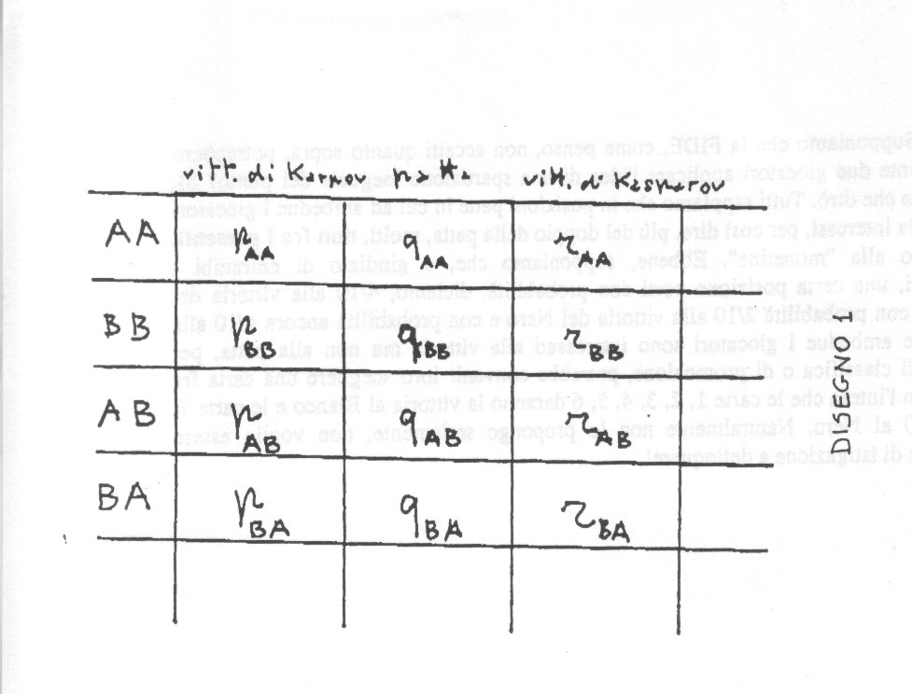
Vedi Tabella 1

Sarebbe più comodo disporre di una rappresentazione in tre dimensioni.
Naturalmente la somma dei tre elementi di una stessa riga deve essere 1.
Per semplificare ancora supponiamo che i due giocatori siano della stessa forza e che, se almeno uno dei due adotta la strategia rischiosa, la probabilità di patta sia 0.
Sia poi k la probabilità di patta se ambedue scelgono la strategia tranquilla.
La tavola diventa:

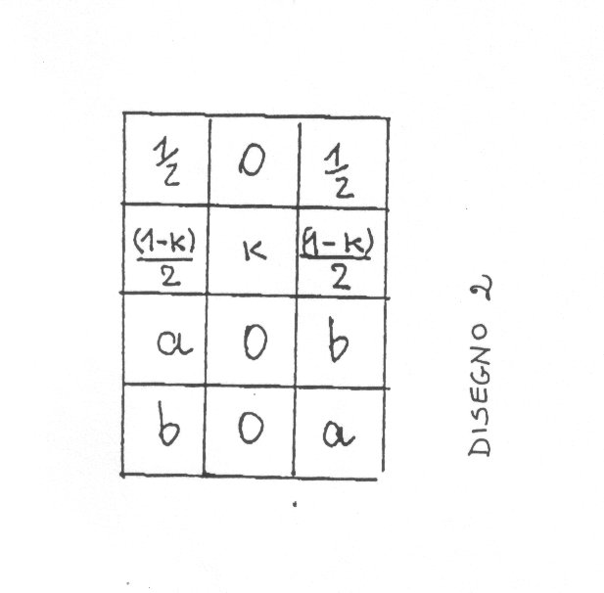
Vedi tabella 2

dove, ovviamente, si dovrà supporre a<b.
E’ ora chiaro che Karpov avrebbe dovuto adottare la strategia "tranquilla".
La scelta della strategia rischiosa per Kasparov risulta valida per a > (l-k)/2.
In effetti nella loro prima sfida la situazione era invertita e si ebbe l'impressione che Karpov avesse scelto, non si sa se a torto o a ragione, perché non sappiamo stimare a, b, k, una strategia "rischiosa".

3. Un'applicazione della teoria di Von Neumann agli scacchi invisibili.
Si chiama gioco degli scacchi invisibili o "Kriegspiel" un gioco in cui si seguono le regole degli scacchi salvo per il fatto che i giocatori non conoscono l'uno le mosse dell'altro.
All'inizio del gioco il Bianco fa una mossa su una sua scacchiera che l'avversario non vede ma viene bensì vista da un arbitro, che avvisa il Nero dicendo "il Bianco ha mosso".
Analogamente muove il Nero ecc. Se ad un certo punto una mossa risulta impossibile l'arbitro lo dice in modo da essere inteso da ambedue i giocatori.
Altre informazioni che l'arbitro da, (sempre ad ambedue i giocatori) se ci
sono le circostanze opportune, sono:
A da scacco in verticale,
A da scacco in orizzontale,
A da scacco sulla grande diagonale (relativamente al Re),
A da scacco sulla piccola diagonale (relativamente al Re),
A da scacco di cavallo,
A prende un pezzo in xy,
Aprende un pedone in xy,
A ha una presa di pedone in xy,
A ha una doppia presa di pedone in xy (e una in zt ecc),
A ha promosso (non si dice a che cosa né in quale colonna),
A ha dato matto,
A ha messo in stallo B.
In questo gioco affascinante chiaramente si possono avere meccanismi di bluff o comunque adatti ad essere trattati in teoria dei giochi alla von Neumann.
E' chiaro che la relazione che passa fra una strategia e un'altra se la prima batte la seconda non è transitiva, può darsi cioè che A batta B che batte C che batte D che batte A.

Una breve partita:
1.e4 (l'arbitro dice "il Bianco ha mosso",
…d5 (l'arbitro dice "II nero ha mosso; il Bianco ha una presa di pedone in d5")
2.e:d5 (l'arbitro dice: "II bianco ha mosso, prendendo un pedone in d5",
…Ag4?! (il nero specula sul fatto che è improbabile che il.Bianco indovini l'attacco
alla sua donna; l'arbitro dice "II Nero ha mosso")
3.f3! (il Bianco ha capito come sono andate le cose o meglio pensa che possano
essere andate così e del resto non sarebbe un gran guaio aver perso un tempo
con 3.f3, l'arbitro dice: "il Bianco ha mosso"), Ad1 (l'arbitro dice
"impossibile" e il nero pensa che, per esempio, può esserci un cavallo
bianco in e2 o in f3, rinuncia al suo tentativo e gioca, diciamo,
…c6). (L'arbitro dice: "II Nero ha mosso; il Bianco ha una presa di pedone in g4".)
4...f:g4 (l'arbitro dice: "il Bianco ha mosso e ha preso un pezzo in g4".)
Non vorrei che questo semplice esempio facesse pensare che il gioco si riduca a meschini trucchetti.
Lo studio dei finali poi è affascinante, con i pezzi avversali che oscillano fra la condizione di corpuscoli e quella di onde di probabilità.
Naturalmente posizioni vinte a scacchi possono essere perse o patte a scacchi invisibili e viceversa.
Occorre inoltre notare che a scacchi invisibili una posizione può essere, anziché semplicemente persa, patta o vinta anche, per esempio, vinta con una cena probabilità. Ciò spiega che si debba usare la teoria dei giochi di von Neumann.
La posizione: Bianco Rc5, Pc6; Nero: Rc7, dove supponiamo per semplicità che all'inizio la posizione sia nota ad ambedue i giocatori, è ovviamente patta, chiunque abbia il tratto, a scacchi ortodossi ed è invece, a scacchi invisibili, "quasi" vinta per il Bianco, nel senso che, detto in breve, il Bianco può scegliere la probabilità che vuole di vincere purché non esiga la certezza.
Per meglio dire comunque preso un numero reale k minore di 1 esiste una strategia per il Bianco che gli da probabilità maggiore di k di vincere.
Ciò se si prescinde da regole del tipo "cinquanta mosse", se invece si pone un limite allora si può calcolare la miglior probabilità che il Bianco può darsi.
Supponiamo il tratto al Nero: egli ha la scelta fra i tratti l...,Rb8, l....,Rc8, 1...,Rd8. A scacchi ortodossi dovrebbe senz'altro giocare Rc8.
Il Bianco giocherà 2.Rb6 o 2.Rd6, supponiamo Rb6.
Se il Nero, al tratto precedente, si è posto in b8 o in d8 ora giocherà 2....,Rc8, altrimenti 2...,Rb8 o 2...,Rd8.
Il Bianco naturalmente non sa a questo punto se il Re nero è in b8, in c8 o in d8.
E' chiaro che se il Re nero fosse in c8 al Bianco converrebbe ora spingere il pedone ma se il Re nero fosse invece in una casa laterale (b8 o d8) questa mossa penerebbe alla patta.
In ogni caso al Bianco, supposto, ricordiamo, in b6, conviene anzitutto tentare 3.Rb7.
Se questa mossa è possibile il Bianco avrà vinto, altrimenti può ancora scegliere se spingere il pedone o tornarsene, diciamo, in c5 per cominciare da capo la manovra.
Se non c'è limite alla lunghezza della partita al Bianco conviene ripetere la manovra senza spingere il pedone se non, diciamo, la k esima volta che tenta.
Il Nero d'altronde deve giocare al secondo tratto della manovra Rc8, altrimenti c'è una probabilità su due che il Bianco si sia posto dal lato giusto e vinca.
Cosi facendo però, quella volta in cui il Bianco spingerà, il Nero si troverà in c8 e perderà.
Perciò al Nero conviene, sembrerebbe, giocare qualche volta al secondo tratto Rb8 o Rd8 e, se lo farà per l'appunto quella volta in cui il Bianco spingerà, la partita sarà patta.
La probabilità di vittoria del Bianco è tanto più grande quanto maggiore è k e anzi tende a 1 al tendere di k all'infinito.
Come analizzare la situazione l'ho spiegato la prima volta nel Manuale di scacchi eterodossi di Mano Leoncini e Roberto Magari, Siena 1980, qui mi limiterò a trattare il caso in cui ci siano limiti alla lunghezza della partita e si sia giunti all'ultima possibile ripetizione della manovra.
In tal caso il Bianco dovrà giocare, dopo il tentativo di avanzare il Re in settima, la spinta, vincendo se il Re nero si troverà in c8 e pattando invece se si troverà in b8 o in d8.
Che cosa deve fare il Nero? Se, al secondo tratto, gioca Rc8 il Bianco, dopo aver tentato inutilmente l'avanzata in settima, giocherà certamente la spinta, vincendo.
Perciò il Nero deve in queste circostanze giocare al secondo tratto Rb8 o Rd8, pattando se il bianco si sarà portato sulla stessa colonna e perdendo altrimenti.
In questo semplice caso quindi la probabilità di vittoria del Bianco è ½; la posizione vale, per così dire, ¾ di punto per il bianco.
Naturalmente, se in futuro si giocheranno tornei di scacchi invisibili, converrà convenire che in questi casi i giocatori possano accordarsi, appunto, per una spartizione ineguale del punto, anche se ciò forse si presterebbe a complessi stratagemmi relativi alla classifica.
Non intendo insistere ma ora saremmo in grado di esaminare la situazione alla penultima manovra tenendo presente che, per l’analisi appena fatta dell’ultima manovra, la situazione varrà ¾ se il Bianco sceglierà di non osare la spinta.
In corrispondenza a questa possibilità del Bianco il Nero deve naturalmente darsi una certa probabilità di giocare 2…, Rc8
Ciò mi ricorda una mia semplice idea relativa invece agli scacchi ordinari, idea, temo, non più interessante del famoso orologio di Fischer ma in tema, come vedremo, con l'argomento che ho trattato.
Anzitutto bisogna dire che le proposte di patta creano spesso qualche disturbo, tanto che il giocatore che vorrebbe proporre la patta può astenersi dal farlo per non disturbare l'avversario e, al contrario, se lo fa troppo spesso in una partita può, credo, essere ammonito dall'arbitro.
Inoltre dopo tutto una offerta di patta è un'informazione che si da all'avversario circa il nostro giudizio sulla posizione.
Per evitare questi inconvenienti basterebbe disporre di qualche semplice congegno equivalente, diciamo a due interruttori in serie con una spia luminosa,
Ciascun giocatore dispone di un interruttore nascosto all'avversario: se lo azione egli viene a proporre la patta e la spia si accenderà se e soltanto se anche l'avversario farà la stessa cosa col suo interruttore.
Ciò si presta ad una complicazione, se, anziché di interruttori, si disponesse di manopole graduate, diciamo, dallo zero al dieci e disposte in modo tale che la spia si accenda se e soltanto se la somma delle due indicazioni è superiore al dieci potremmo proporre senza disturbare l'avversario, una spartizione del punto in pani disuguali.
Io valuto, supponiamo, la mia posizione come avente tre probabilità su dieci e propongo con la mia manopola sistemata sul 3, una spartizione in cui a me tocchino tre decimi di punto e all'avversario sette.
La spia si accenderà se, regolando la sua manopola, l'avversario avrà indicato di contentarsi di sette decimi di punto o meno (nel caso in cui la sua indicazione sia minore si potrebbe spartire l'eccesso in pani proporzionali.
Naturalmente occorre dire, anche qui, che la faccenda si presterebbe a sottili stratagemmi per la posizione in classifica.
Supponiamo che la FIDE, come penso, non accetti quanto sopra, potrebbero egualmente due giocatori applicare l'idea di una spartizione ineguale del punto?
SI, nel senso che dirò.
Tutti sappiamo che in posizioni patte in cui ad ambedue i giocatori la vittoria interessi, per così dire, più del doppio della patta, molti, non fra i presenti, ricorrono alla "monetina".
Ebbene, supponiamo che, a giudizio di entrambi i giocatori, una certa posizione porti con probabilità, diciamo, 4/10 alla vittoria del Bianco, con probabilità 2/10 alla vittoria del Nero e con probabilità ancora 4/10 alla patta.
Se ambedue i giocatori sono interessati alla vittoria ma non alla patta, per motivi di classifica o di promozione, potrebbe convenire loro di scegliere una carta fra dieci con l'intesa che le carte 1,2, 3,4,5, 6 daranno la vittoria al Bianco e le carte 7, 8, 9, 10 al Nero.
Naturalmente non lo propongo seriamente, non voglio essere accusato di istigazione a delinquere!

Roberto Magari

